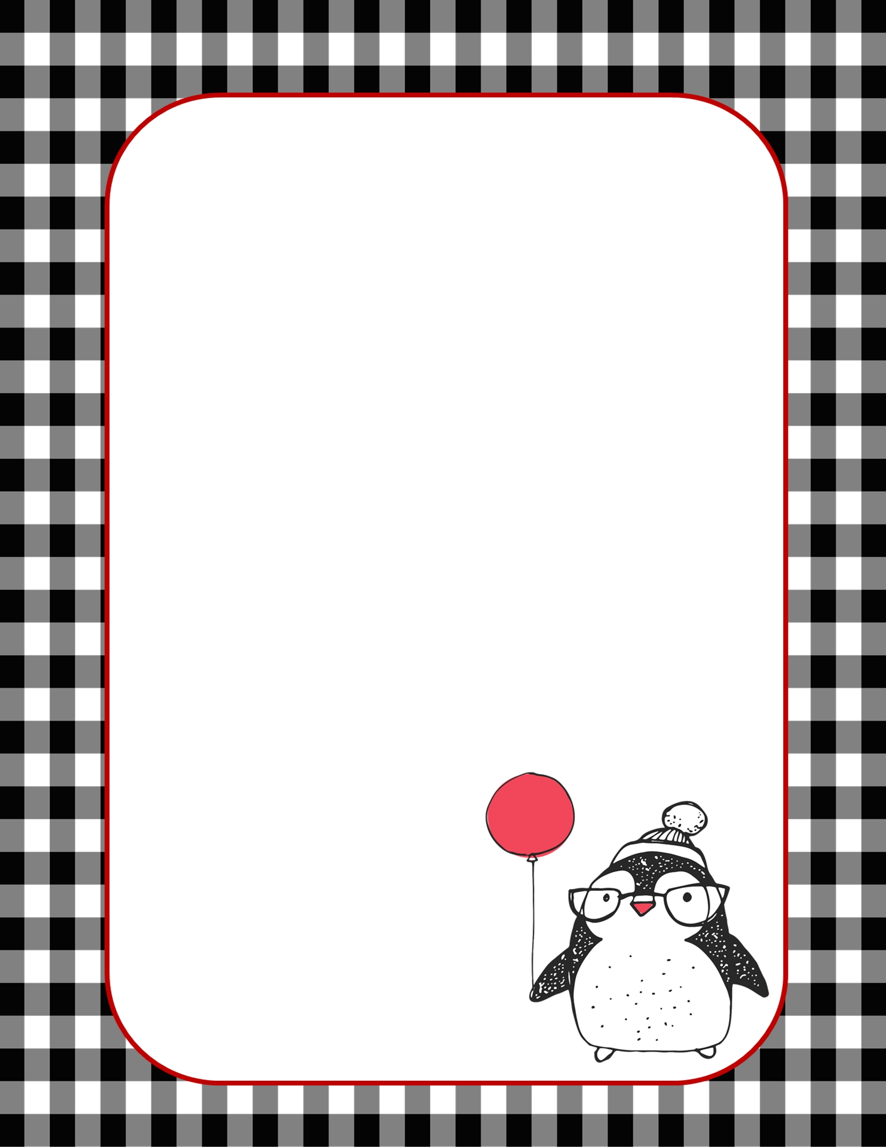
Name: _____________

Favorite things

One thing you can’t live without?
One thing you always need more of? |  |  | Preferences
What do you like to splurge on? |  |  |  | ✓ | ✗
Favorite store: |  |  | Books | ☐ | ☐
Favorite color: |  |  | Gadgets | ☐ | ☐
Favorite book: |  |  | Stationery | ☐ | ☐
Favorite flower: |  |  | Jewellery | ☐ | ☐
 |  |  | Art | ☐ | ☐
Food |  |  | Stationery | ☐ | ☐
Favorite food: |  |  | Chocolates | ☐ | ☐
Favorite candy: |  |  | Home Decor | ☐ | ☐
Favorite beverage: |  |  | Candles | ☐ | ☐
Favorite comfort food: |  |  | Plants | ☐ | ☐
Do you have any allergies? |  |  | Gift Card | ☐ | ☐
Sports
Do you play any sports?
Favorite team:
Do you enjoy any outdoor activities?
Hobbies
What are your hobbies:
What do you like to do in your free time?
Do you collect anything?
I absolutely love:
But, please, stay away from this:

