Weekly Planner

Week of |  | Healthy Habit for the Week |  |  | 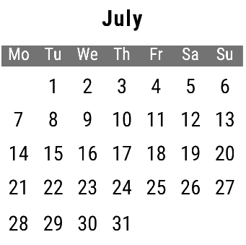

Wednesday | Tuesday | Monday |  | Weekly Goals
 |  |  |  | Top 3 Priorities
 |  |  |  | To Do
Saturday | Friday | Thursday
Sunday
 |  |  |  | Next Week

