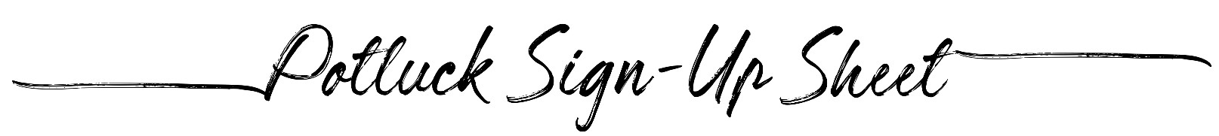

Event: | Date:
Time: | Number of People:
Side Dishes
Name |  | I will bring:
Main Dishes
Name |  | I will bring:
Drinks
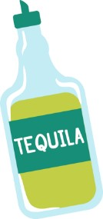  Name |  | I will bring:
Desserts
Name |  | I will bring:

