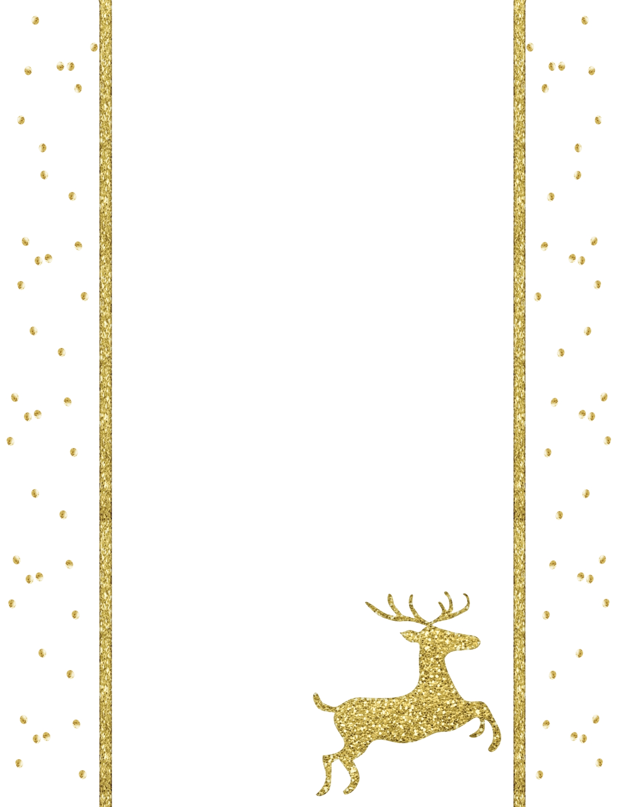

Dear Santa,  
____________________________________________________________________________________________________________________________________________________________________________________________________________________________________________________________________________________________________________________________________________________________________________________________________________________________________________________________

Love,

**Letter to Santa**