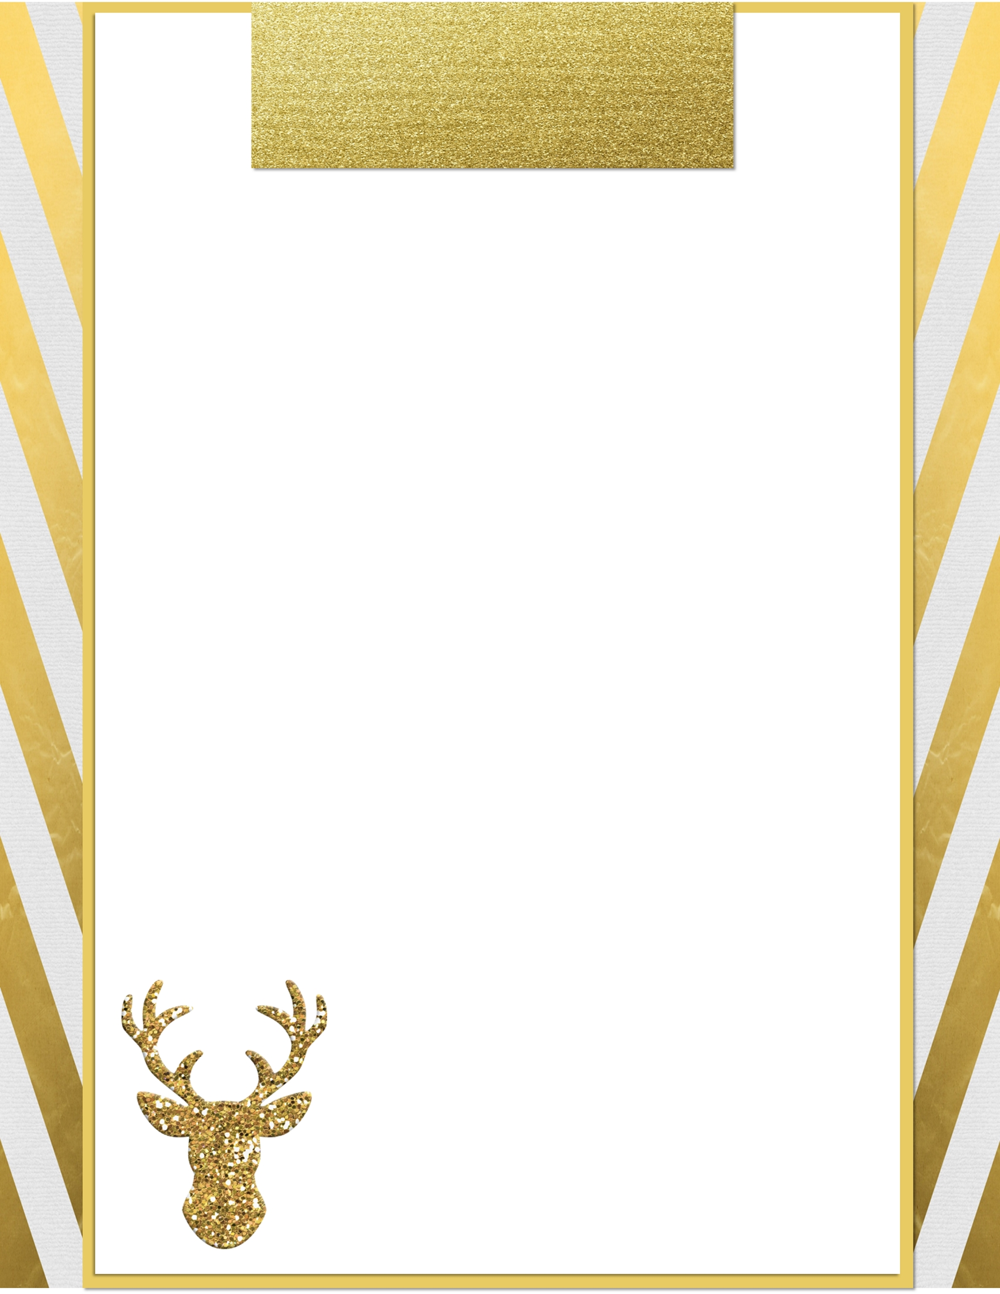

Dear Santa,  
________________________________________________________________________________________________________________________________________________________________________________________________________________________________________________________________________________________________________________________________________________________________________________________________________________________________________________________________________________________________________________________________________________

Love,

**Letter to Santa**