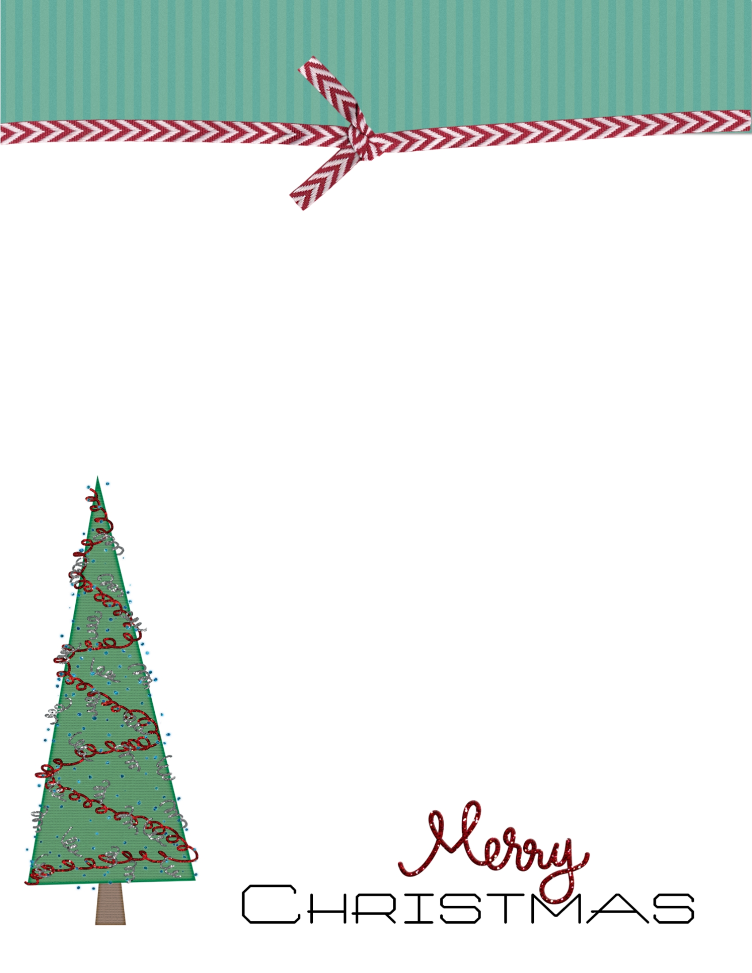

Dear Santa,  
____________________________________________________________________________________________________________________________________________________________________________________________________________________________________________________________________________________________________________________________________________________________________________________________________________________________________________________________________________________________________

Love,

**Letter to Santa**