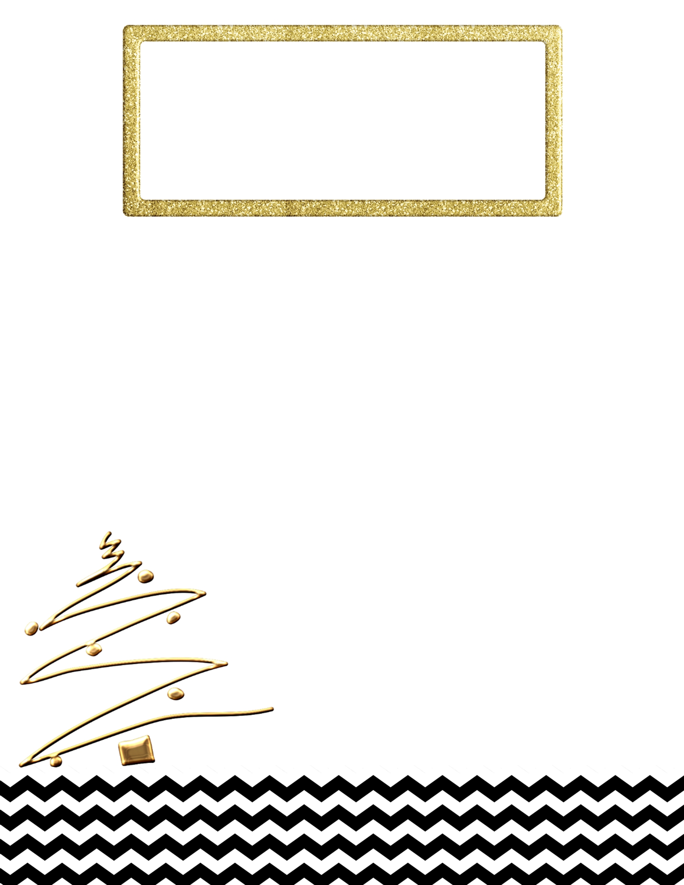

**Letter to Santa**

Dear Santa,  
________________________________________________________________________________________________________________________________________________________________________________________________________________________________________________________________________________________________________________________________________________________________________________________________

Love,

___________________