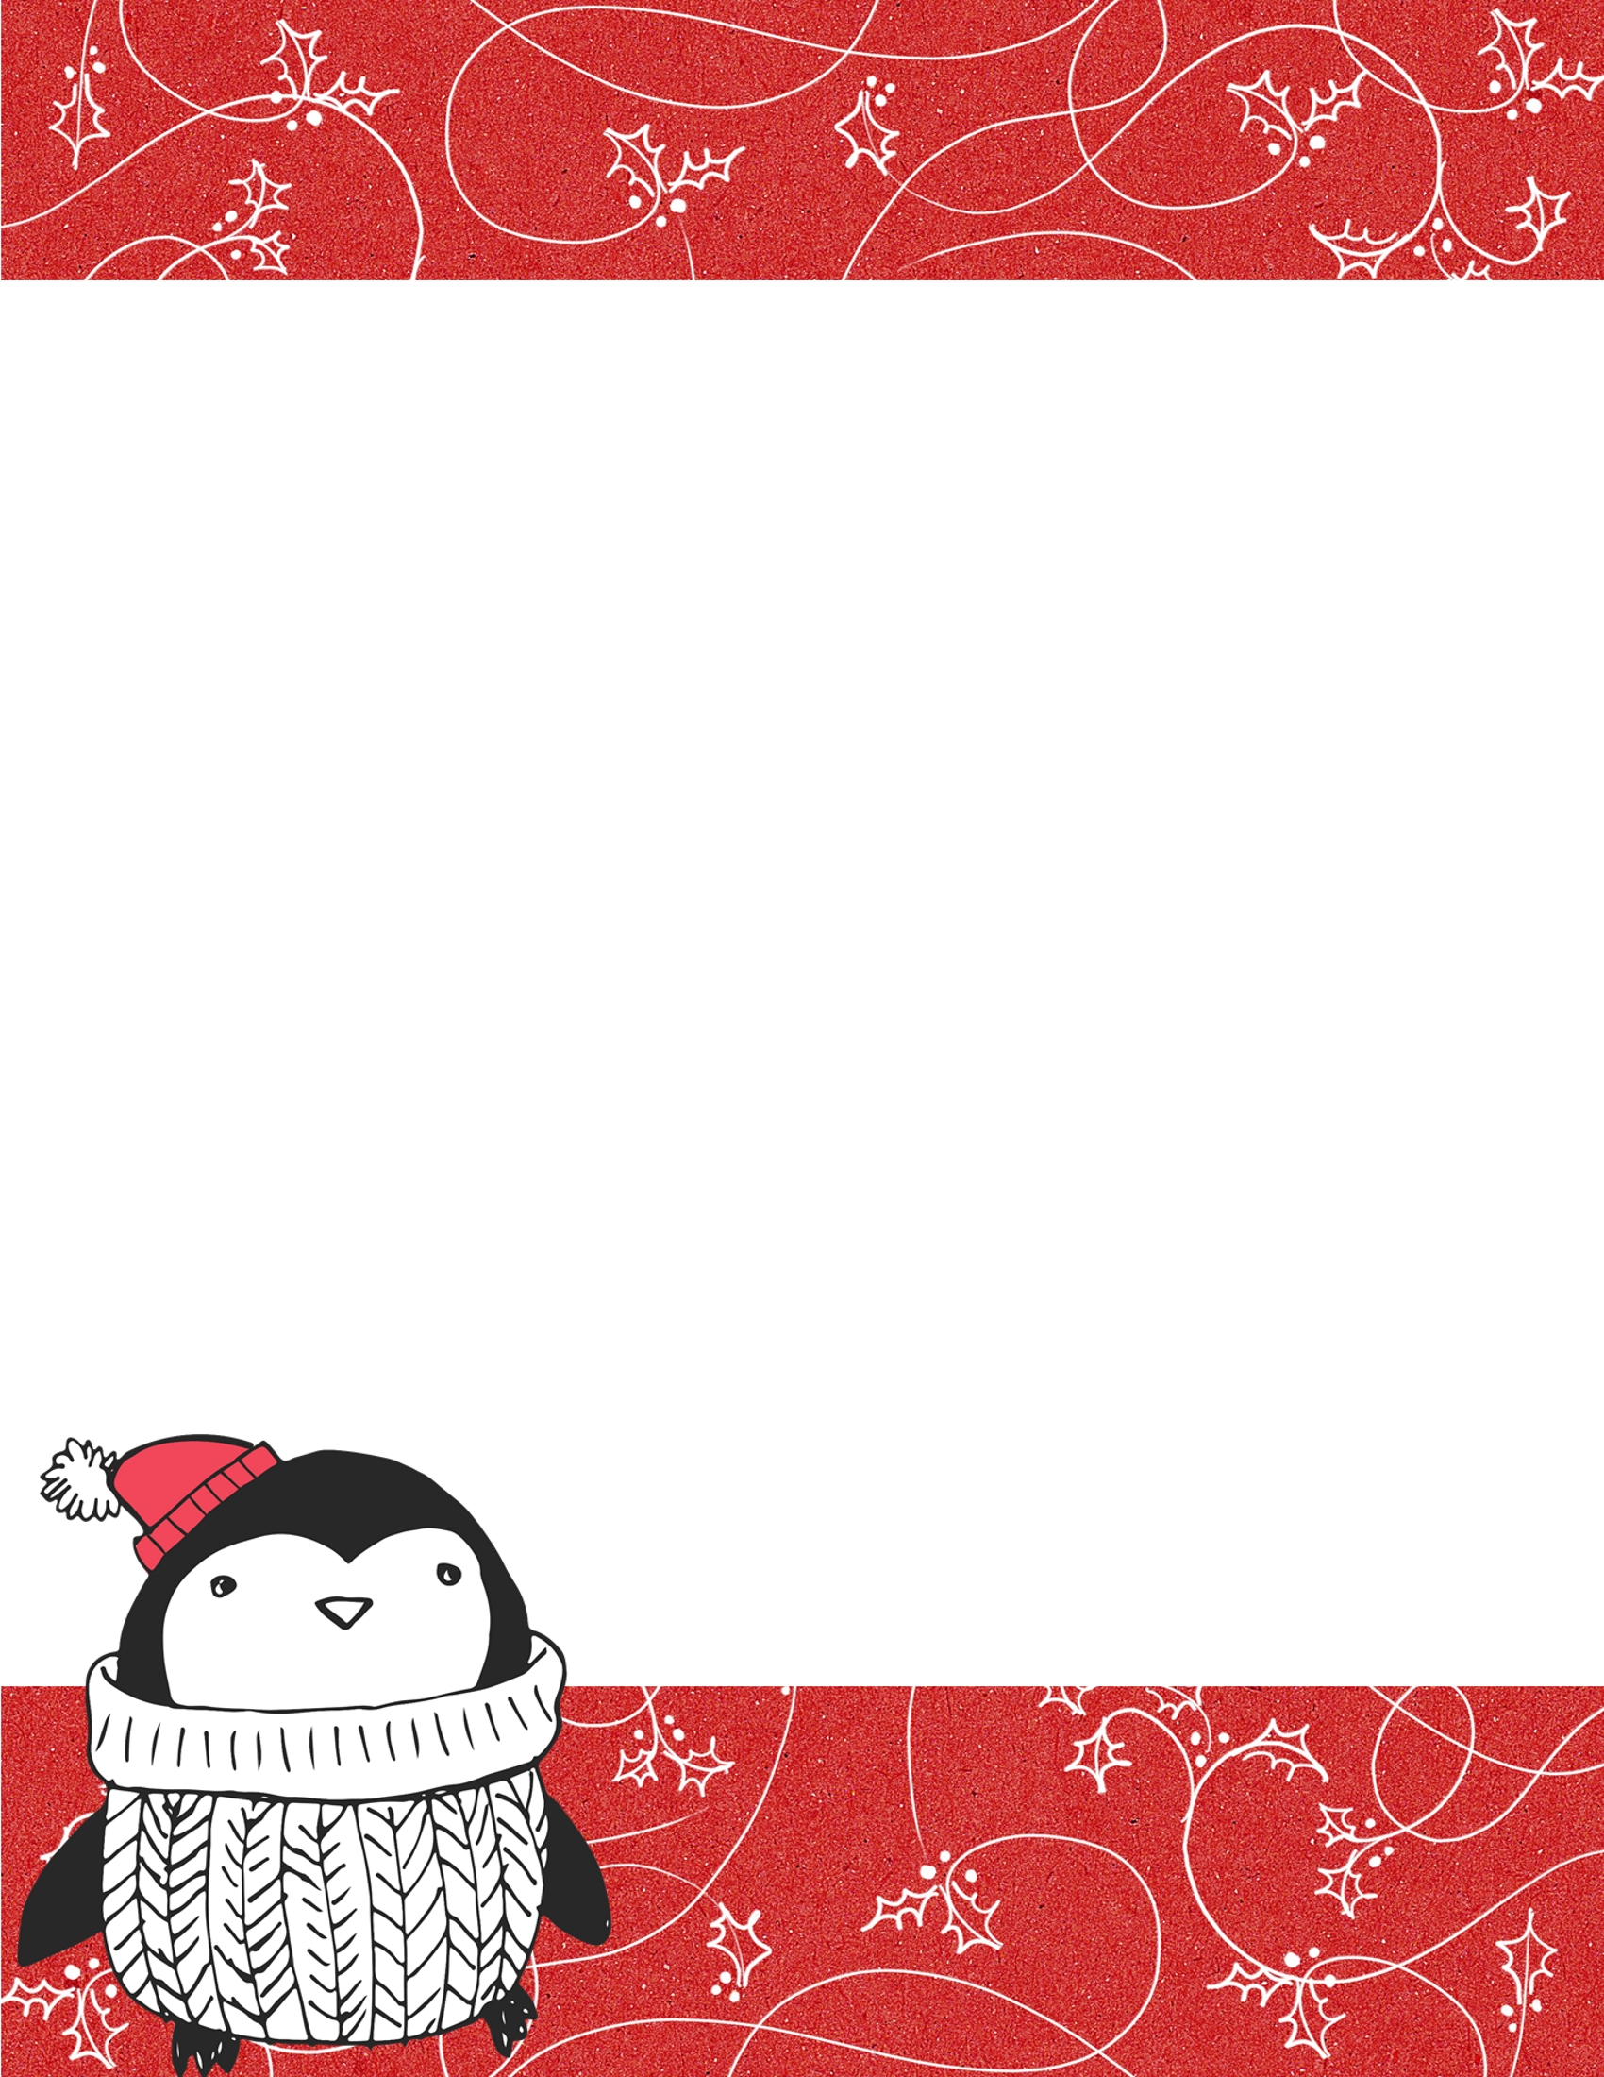
https://www.create.101planners.com/wp-content/uploads/2022/10/Letter-to-Santa-3.docxhttps://www.create.101planners.com/wp-content/uploads/2022/10/Letter-to-Santa-3.docx
Dear Santa,
________________________________________________________________________________________________________________________________________________________________________________________________________________________________________________________________________________________________________________________________________________________________________________________________________________________________________________
Love,
___________________

