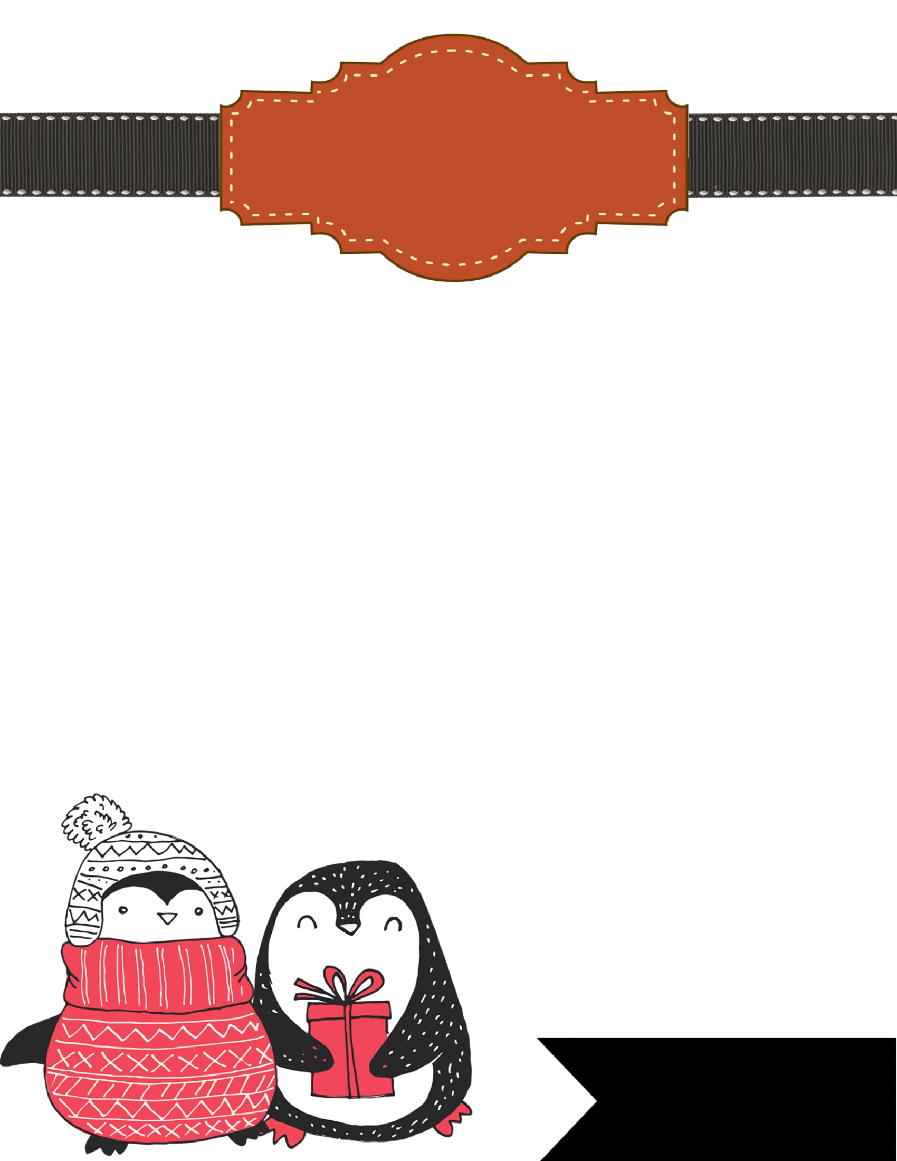

Dear Santa,  
________________________________________________________________________________________________________________________________________________________________________________________________________________________________________________________________________________________________________________________________________________

Love,