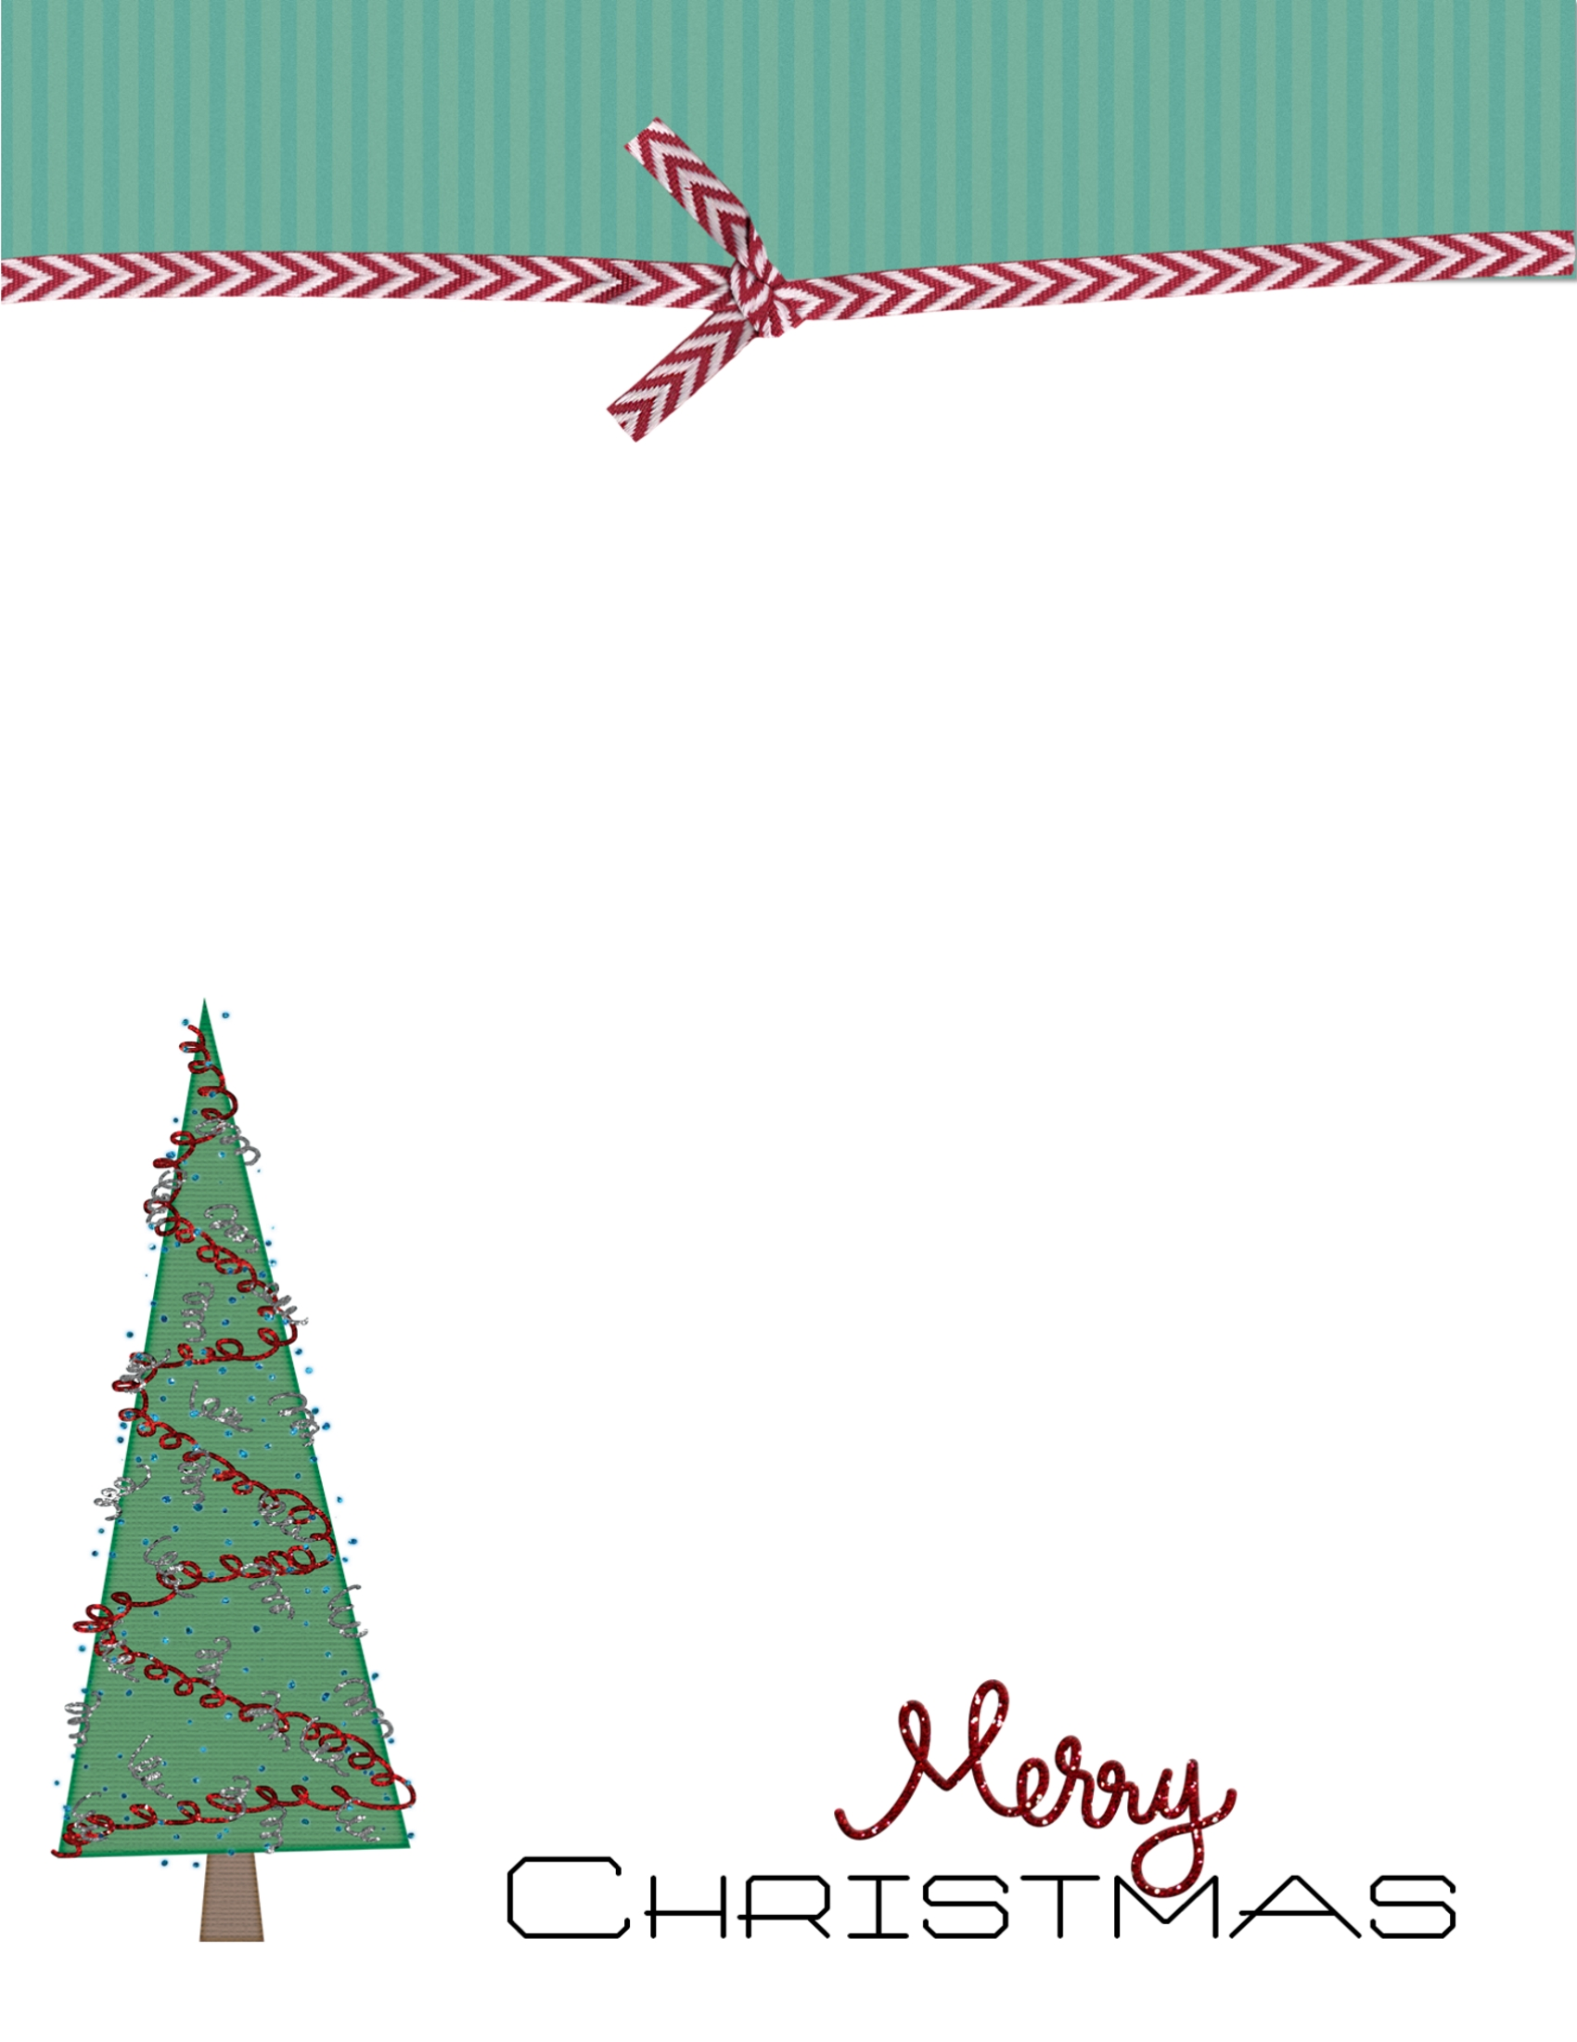

Dear [Your Child's Name],

Merry Christmas from the North Pole!

I wanted to personally let you know that your name appears on the nice list.

I am so proud that you (add the child's achievements here).

Your parents are also very proud of you!

Please send me a list of what you would like to see under your tree this year.

Keep being the good, kind and giving person that you are.

With love,

Santa Claus

North Pole