 |  |  | 1 | 2 | 3 | 4
 |  |  | 1st of Tevet, 5785 Chanukah: 8Candles Rosh ChodeshTevet | 2nd of Tevet, 5785 Chanukah: 8thDay | 3rd of Tevet, 5785 | 4th of Tevet, 5785
5 | 6 | 7 | 8 | 9 | 10 | 11
5th of Tevet, 5785 | 6th of Tevet, 5785 | 7th of Tevet, 5785 | 8th of Tevet, 5785 | 9th of Tevet, 5785 | 10th of Tevet, 5785 | 11th of Tevet, 5785
12 | 13 | 14 | 15 | 16 | 17 | 18
12th of Tevet, 5785 | 13th of Tevet, 5785 | 14th of Tevet, 5785 | 15th of Tevet, 5785 | 16th of Tevet, 5785 | 17th of Tevet, 5785 | 18th of Tevet, 5785
19 | 20 | 21 | 22 | 23 | 24 | 25
19th of Tevet, 5785 | 20th of Tevet, 5785 | 21st of Tevet, 5785 | 22nd of Tevet, 5785 | 23rd of Tevet, 5785 | 24th of Tevet, 5785 | 25th of Tevet, 5785
26 | 27 | 28 | 29 | 30 | 31
26th of Tevet, 5785 | 27th of Tevet, 5785 | 28th of Tevet, 5785 | 29th of Tevet, 5785 | 1st of Sh'vat, 5785 Rosh ChodeshSh'vat | 2nd of Sh'vat, 5785
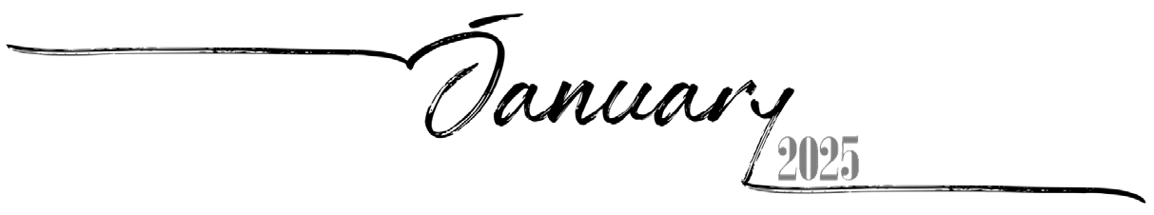

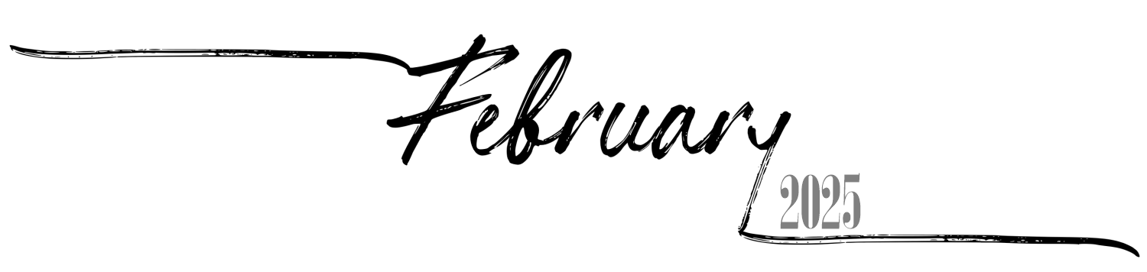
Sunday Monday Tuesday
 |  |  |  |  |  | 3rd of Sh'vat, 5785
2 | 3 | 4 | 5 | 6 | 7 | 8
4th of Sh'vat, 5785 | 5th of Sh'vat, 5785 | 6th of Sh'vat, 5785 | 7th of Sh'vat, 5785 | 8th of Sh'vat, 5785 | 9th of Sh'vat, 5785 | 10th of Sh'vat, 5785
9 | 10 | 11 | 12 | 13 | 14 | 15
11th of Sh'vat, 5785 | 12th of Sh'vat, 5785 | 13th of Sh'vat, 5785 | 14th of Sh'vat, 5785 | 15th of Sh'vat, 5785 Tu BiShvat | 16th of Sh'vat, 5785 | 17th of Sh'vat, 5785
16 | 17 | 18 | 19 | 20 | 21 | 22
18th of Sh'vat, 5785 | 19th of Sh'vat, 5785 | 20th of Sh'vat, 5785 | 21st of Sh'vat, 5785 | 22nd of Sh'vat, 5785 | 23rd of Sh'vat, 5785 | 24th of Sh'vat, 5785
23 | 24 | 25 | 26 | 27 | 28
25th of Sh'vat, 5785 | 26th of Sh'vat, 5785 | 27th of Sh'vat, 5785 | 28th of Sh'vat, 5785 | 29th of Sh'vat, 5785 | 30th of Sh'vat, 5785 Rosh ChodeshAdar

Wednesday
Thursday Friday Saturday
1

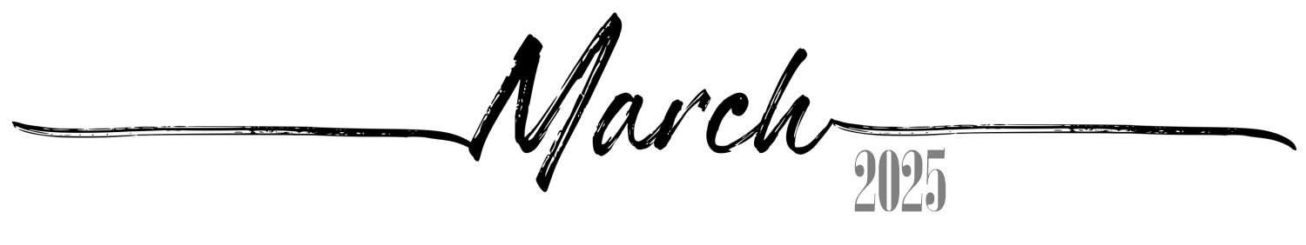
 |  |  |  |  |  | 1
 |  |  |  |  |  | 1st of Adar, 5785 Rosh Chodesh Adar
2 | 3 | 4 | 5 | 6 | 7 | 8
2nd of Adar, 5785 | 3rd of Adar, 5785 | 4th of Adar, 5785 | 5th of Adar, 5785 | 6th of Adar, 5785 | 7th of Adar, 5785 | 8th of Adar, 5785
9 | 10 | 11 | 12 | 13 | 14 | 15
9th of Adar, 5785 | 10th of Adar, 5785 | 11th of Adar, 5785 | 12th of Adar, 5785 | 13th of Adar, 5785 Erev Purim | 14th of Adar, 5785 Purim | 15th of Adar, 5785
16 | 17 | 18 | 19 | 20 | 21 | 22
16th of Adar, 5785 Shushan Purim | 17th of Adar, 5785 | 18th of Adar, 5785 | 19th of Adar, 5785 | 20th of Adar, 5785 | 21st of Adar, 5785 | 22nd of Adar, 5785
23 | 24 | 25 | 26 | 27 | 28 | 29
23rd of Adar, 5785 | 24th of Adar, 5785 | 25th of Adar, 5785 | 26th of Adar, 5785 | 27th of Adar, 5785 | 28th of Adar, 5785 | 29th of Adar, 5785
30 | 31
1st of Nisan, 5785 Rosh Chodesh Nisan | 2nd of Nisan, 5785

 |  | 1 | 2 | 3 | 4 | 5
 |  | 3rd of Nisan, 5785 | 4th of Nisan, 5785 | 5th of Nisan, 5785 | 6th of Nisan, 5785 | 7th of Nisan, 5785
6 | 7 | 8 | 9 | 10 | 11 | 12
8th of Nisan, 5785 | 9th of Nisan, 5785 | 10th of Nisan, 5785 Yom HaAliyah | 11th of Nisan, 5785 | 12th of Nisan, 5785 | 13th of Nisan, 5785 | 14th of Nisan, 5785 Erev Pesach
13 | 14 | 15 | 16 | 17 | 18 | 19
15th of Nisan, 5785  Pesach I | 16th of Nisan, 5785  Pesach II | 17th of Nisan, 5785 Pesach III(CH''M) | 18th of Nisan, 5785 Pesach IV(CH''M) | 19th of Nisan, 5785 Pesach V(CH''M) | 20th of Nisan, 5785 Pesach VI(CH''M) | 21st of Nisan, 5785  Pesach VII
20 | 21 | 22 | 23 | 24 | 25 | 26
22nd of Nisan, 5785  Pesach VIII | 23rd of Nisan, 5785 | 24th of Nisan, 5785 | 25th of Nisan, 5785 | 26th of Nisan, 5785 Yom HaShoah | 27th of Nisan, 5785 | 28th of Nisan, 5785
27 | 28 | 29 | 30
29th of Nisan, 5785 | 30th of Nisan, 5785 Rosh ChodeshIyyar | 1st of Iyyar, 5785 Rosh ChodeshIyyar | 2nd of Iyyar, 5785 Yom HaZikaron
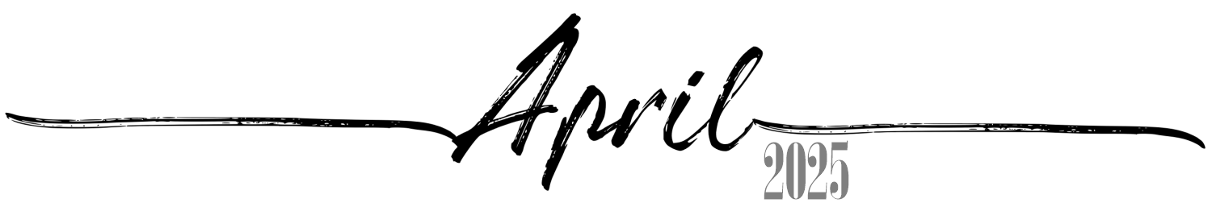

 |  |  |  | 1 | 2 | 3
 |  |  |  | 3rd of Iyyar, 5785 Yom HaAtzma'ut | 4th of Iyyar, 5785 | 5th of Iyyar, 5785
4 | 5 | 6 | 7 | 8 | 9 | 10
6th of Iyyar, 5785 | 7th of Iyyar, 5785 | 8th of Iyyar, 5785 | 9th of Iyyar, 5785 | 10th of Iyyar, 5785 | 11th of Iyyar, 5785 | 12th of Iyyar, 5785
11 | 12 | 13 | 14 | 15 | 16 | 17
13th of Iyyar, 5785 | 14th of Iyyar, 5785 Pesach Sheni | 15th of Iyyar, 5785 | 16th of Iyyar, 5785 | 17th of Iyyar, 5785 | 18th of Iyyar, 5785 Lag BaOmer | 19th of Iyyar, 5785
18 | 19 | 20 | 21 | 22 | 23 | 24
20th of Iyyar, 5785 | 21st of Iyyar, 5785 | 22nd of Iyyar, 5785 | 23rd of Iyyar, 5785 | 24th of Iyyar, 5785 | 25th of Iyyar, 5785 | 26th of Iyyar, 5785
25 | 26 | 27 | 28 | 29 | 30 | 31
27th of Iyyar, 5785 | 28th of Iyyar, 5785 YomYerushalayim | 29th of Iyyar, 5785 | 1st of Sivan, 5785 Rosh Chodesh Sivan | 2nd of Sivan, 5785 | 3rd of Sivan, 5785 | 4th of Sivan, 5785
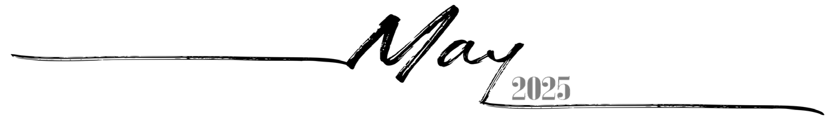

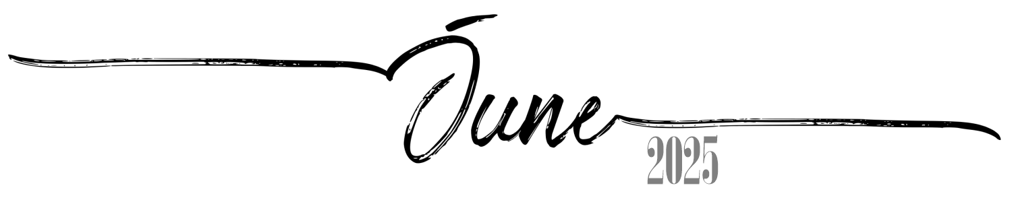
1 | 2 | 3 | 4 | 5 | 6 | 7
5th of Sivan, 5785 Erev Shavuos | 6th of Sivan, 5785  Shavuos I | 7th of Sivan, 5785  Shavuos II | 8th of Sivan, 5785 | 9th of Sivan, 5785 | 10th of Sivan, 5785 | 11th of Sivan, 5785
8 | 9 | 10 | 11 | 12 | 13 | 14
12th of Sivan, 5785 | 13th of Sivan, 5785 | 14th of Sivan, 5785 | 15th of Sivan, 5785 | 16th of Sivan, 5785 | 17th of Sivan, 5785 | 18th of Sivan, 5785
15 | 16 | 17 | 18 | 19 | 20 | 21
19th of Sivan, 5785 | 20th of Sivan, 5785 | 21st of Sivan, 5785 | 22nd of Sivan, 5785 | 23rd of Sivan, 5785 | 24th of Sivan, 5785 | 25th of Sivan, 5785
22 | 23 | 24 | 25 | 26 | 27 | 28
26th of Sivan, 5785 | 27th of Sivan, 5785 | 28th of Sivan, 5785 | 29th of Sivan, 5785 | 30th of Sivan, 5785 Rosh ChodeshTamuz | 1st of Tamuz, 5785 Rosh ChodeshTamuz | 2nd of Tamuz, 5785
29 | 30
3rd of Tamuz, 5785 | 4th of Tamuz, 5785

 |  | 1 | 2 | 3 | 4 | 5
 |  | 5th of Tamuz, 5785 | 6th of Tamuz, 5785 | 7th of Tamuz, 5785 | 8th of Tamuz, 5785 | 9th of Tamuz, 5785
6 | 7 | 8 | 9 | 10 | 11 | 12
10th of Tamuz, 5785 | 11th of Tamuz, 5785 | 12th of Tamuz, 5785 | 13th of Tamuz, 5785 | 14th of Tamuz, 5785 | 15th of Tamuz, 5785 | 16th of Tamuz, 5785
13 | 14 | 15 | 16 | 17 | 18 | 19
17th of Tamuz, 5785 | 18th of Tamuz, 5785 | 19th of Tamuz, 5785 | 20th of Tamuz, 5785 | 21st of Tamuz, 5785 | 22nd of Tamuz, 5785 | 23rd of Tamuz, 5785
20 | 21 | 22 | 23 | 24 | 25 | 26
24th of Tamuz, 5785 | 25th of Tamuz, 5785 | 26th of Tamuz, 5785 | 27th of Tamuz, 5785 | 28th of Tamuz, 5785 | 29th of Tamuz, 5785 | 1st of Av, 5785 Rosh Chodesh Av
27 | 28 | 29 | 30 | 31
2nd of Av, 5785 | 3rd of Av, 5785 | 4th of Av, 5785 | 5th of Av, 5785 | 6th of Av, 5785
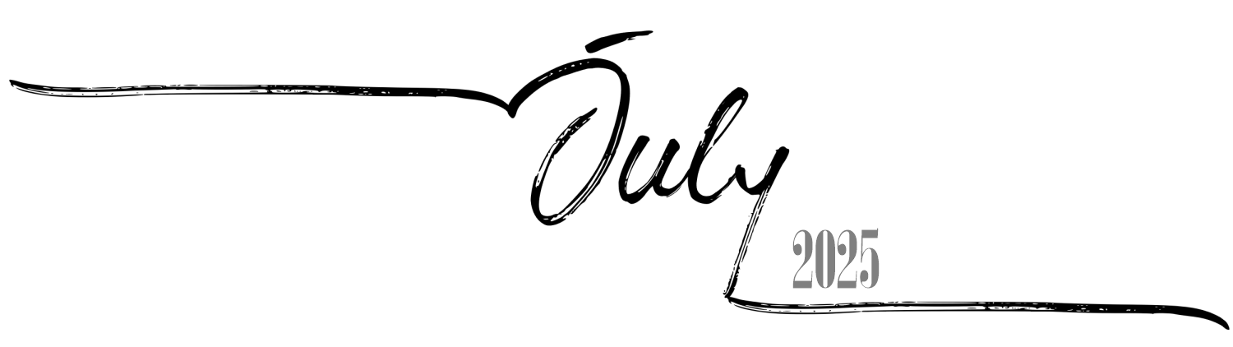

 |  |  |  |  | 1 | 2
 |  |  |  |  | 7th of Av, 5785 | 8th of Av, 5785 Erev Tish'a B'Av
3 | 4 | 5 | 6 | 7 | 8 | 9
9th of Av, 5785 Tish'a B'Av | 10th ofAv, 5785 | 11th ofAv, 5785 | 12th of Av, 5785 | 13th of Av, 5785 | 14th of Av, 5785 | 15th of Av, 5785 Tu B'Av
10 | 11 | 12 | 13 | 14 | 15 | 16
16th ofAv, 5785 | 17th ofAv, 5785 | 18th ofAv, 5785 | 19th of Av, 5785 | 20th of Av, 5785 | 21st ofAv, 5785 | 22nd of Av, 5785
17 | 18 | 19 | 20 | 21 | 22 | 23
23rd ofAv, 5785 | 24th ofAv, 5785 | 25th ofAv, 5785 | 26th of Av, 5785 | 27th of Av, 5785 | 28th of Av, 5785 | 29th ofAv, 5785
24 | 25 | 26 | 27 | 28 | 29 | 30
30th of Av, 5785 Rosh Chodesh Elul | 1st of Elul, 5785  Rosh HashanaLaBehemot  Rosh ChodeshElul | 2nd of Elul, 5785 | 3rd of Elul, 5785 | 4th of Elul, 5785 | 5th of Elul, 5785 | 6th of Elul, 5785
31
7th of Elul, 5785
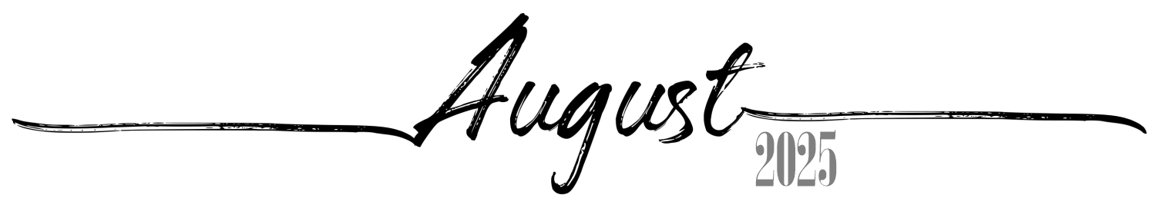

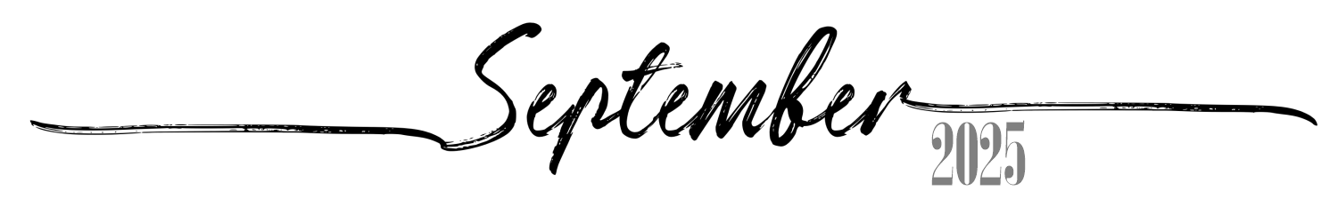
Sunday
Monday
Tuesday
Wednesday
Thursday
Friday
Saturday
 | 1 | 2 | 3 | 4 | 5 | 6
 | 8th of Elul, 5785 | 9th of Elul, 5785 | 10th of Elul, 5785 | 11th of Elul, 5785 | 12th of Elul, 5785 | 13th of Elul, 5785
7 | 8 | 9 | 10 | 11 | 12 | 13
14th of Elul, 5785 | 15th of Elul, 5785 | 16th of Elul, 5785 | 17th of Elul, 5785 | 18th of Elul, 5785 | 19th of Elul, 5785 | 20th of Elul, 5785 Leil Selichos
14 | 15 | 16 | 17 | 18 | 19 | 20
21st of Elul, 5785 | 22nd of Elul, 5785 | 23rd of Elul, 5785 | 24th of Elul, 5785 | 25th of Elul, 5785 | 26th of Elul, 5785 | 27th of Elul, 5785
21 | 22 | 23 | 24 | 25 | 26 | 27
28th of Elul, 5785 | 29th of Elul, 5785 Erev RoshHashana | 1st of Tishrei, 5786  Rosh Hashana5786 | 2nd of Tishrei, 5786  Rosh Hashana II | 3rd of Tishrei, 5786 | 4th of Tishrei, 5786 | 5th of Tishrei, 5786
28 | 29 | 30
6th of Tishrei, 5786 | 7th of Tishrei, 5786 | 8th of Tishrei, 5786

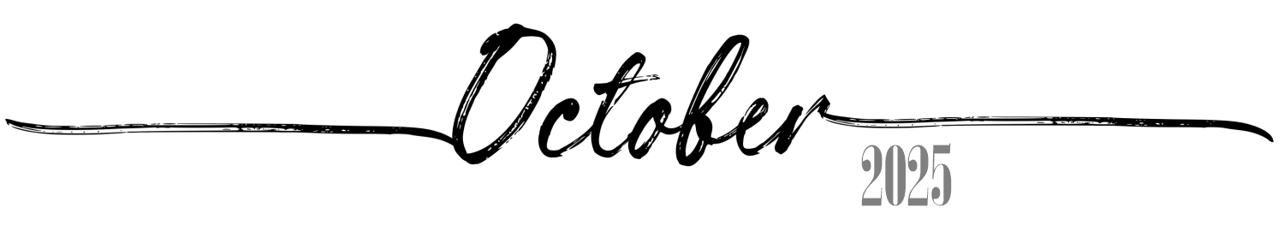
 |  |  | 1  9th of Tishrei, 5786 Erev YomKippur | 2  10th of Tishrei, 5786  Yom Kippur | 3 | 4
 |  |  |  |  | 11th of Tishrei, 5786 | 12th of Tishrei, 5786
5 | 6 | 7 | 8  16th of Tishrei, 5786  Sukkos II | 9  17th of Tishrei, 5786 Sukkos III(CH''M) | 10 | 11
13th of Tishrei, 5786 | 14th of Tishrei, 5786 Erev Sukkos | 15th of Tishrei, 5786  Sukkos I |  |  | 18th of Tishrei, 5786 Sukkos IV(CH''M) | 19th of Tishrei, 5786 Sukkos V(CH''M)
12 | 13 | 14 | 15  23rd of Tishrei, 5786  Simchas Torah | 16  24th of Tishrei, 5786 | 17 | 18
20th of Tishrei, 5786 Sukkos VI(CH''M) | 21st of Tishrei, 5786  Sukkos VII (HoshanaRaba) | 22nd of Tishrei, 5786  Shmini Atzeres |  |  | 25th of Tishrei, 5786 | 26th of Tishrei, 5786
19 | 20 | 21 | 22  30th of Tishrei, 5786 Rosh ChodeshCheshvan | 23  1st of Cheshvan, 5786 Rosh ChodeshCheshvan | 24 | 25
27th of Tishrei, 5786 | 28th of Tishrei, 5786 | 29th of Tishrei, 5786 |  |  | 2nd of Cheshvan, 5786 | 3rd of Cheshvan, 5786
26 | 27 | 28 | 29  7th of Cheshvan, 5786  Yom HaAliyah School Observance | 30  8th of Cheshvan, 5786 | 31
4th of Cheshvan, 5786 | 5th of Cheshvan, 5786 | 6th of Cheshvan, 5786 |  |  | 9th of Cheshvan, 5786

 |  |  |  |  |  | 1
 |  |  |  |  |  | 10th of Cheshvan, 5786
2 | 3 | 4 | 5 | 6 | 7 | 8
11th of Cheshvan, 5786 | 12th of Cheshvan, 5786 | 13th of Cheshvan, 5786 | 14th of Cheshvan, 5786 | 15th of Cheshvan, 5786 | 16th of Cheshvan, 5786 | 17th of Cheshvan, 5786
9 | 10 | 11 | 12 | 13 | 14 | 15
18th of Cheshvan, 5786 | 19th of Cheshvan, 5786 | 20th of Cheshvan, 5786 | 21st of Cheshvan, 5786 | 22nd of Cheshvan, 5786 | 23rd of Cheshvan, 5786 | 24th of Cheshvan, 5786
16 | 17 | 18 | 19 | 20 | 21 | 22
25th of Cheshvan, 5786 | 26th of Cheshvan, 5786 | 27th of Cheshvan, 5786 | 28th of Cheshvan, 5786 | 29th of Cheshvan, 5786 Sigd | 1st of Kislev, 5786 Rosh ChodeshKislev | 2nd of Kislev, 5786
23 | 24 | 25 | 26 | 27 | 28 | 29
3rd of Kislev, 5786 | 4th of Kislev, 5786 | 5th of Kislev, 5786 | 6th of Kislev, 5786 | 7th of Kislev, 5786 | 8th of Kislev, 5786 | 9th of Kislev, 5786
30
10th of Kislev, 5786
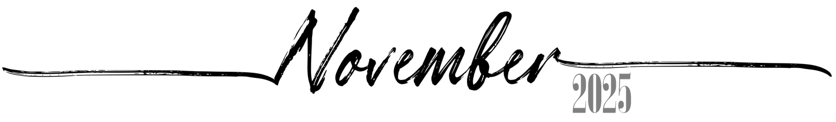

 | 1  11th of Kislev, 5786 | 2  12th of Kislev, 5786 | 3  13th of Kislev, 5786 | 4  14th of Kislev, 5786 | 5  15th of Kislev, 5786 | 6  16th of Kislev, 5786
7  17th of Kislev, 5786 | 8  18th of Kislev, 5786 | 9  19th of Kislev, 5786 | 10  20th of Kislev, 5786 | 11  21st of Kislev, 5786 | 12  22nd of Kislev, 5786 | 13  23rd of Kislev, 5786
14  24th of Kislev, 5786 Chanukah:1 Candle | 15  25th of Kislev, 5786 Chanukah: 2Candles | 16  26th of Kislev, 5786 Chanukah: 3Candles | 17  27th of Kislev, 5786 Chanukah: 4Candles | 18  28th of Kislev, 5786 Chanukah: 5Candles | 19  29th of Kislev, 5786 Chanukah: 6Candles | 20  30th of Kislev, 5786 Chanukah: 7Candles Rosh ChodeshTevet
21  1st of Tevet, 5786 Chanukah: 8Candles Rosh ChodeshTevet | 22  2nd of Tevet, 5786 Chanukah: 8thDay | 23  3rd of Tevet, 5786 | 24  4th of Tevet, 5786 | 25  5th of Tevet, 5786 | 26  6th of Tevet, 5786 | 27  7th of Tevet, 5786
28  8th of Tevet, 5786 | 29  9th of Tevet, 5786 | 30  10th of Tevet, 5786 | 31  11th of Tevet, 5786
