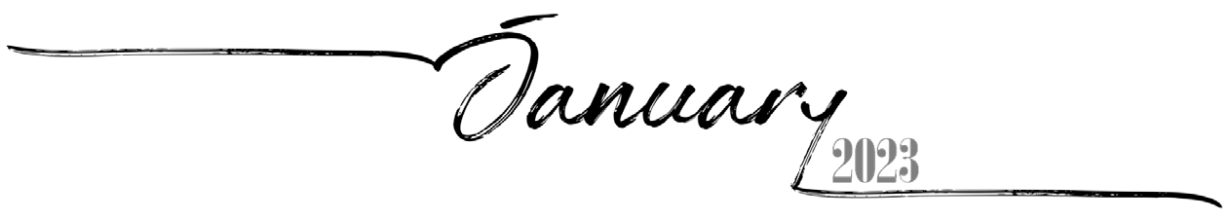
1 | 2 | 3 | 4 | 5 | 6 | 7
8th of Tevet, 5783 | 9th of Tevet, 5783 | 10th of Tevet, 5783 | 11th of Tevet, 5783 | 12th of Tevet, 5783 | 13th of Tevet, 5783 | 14th of Tevet, 5783
8 | 9 | 10 | 11 | 12 | 13 | 14
15th of Tevet, 5783 | 16th of Tevet, 5783 | 17th of Tevet, 5783 | 18th of Tevet, 5783 | 19th of Tevet, 5783 | 20th of Tevet, 5783 | 21st of Tevet, 5783
15 | 16 | 17 | 18 | 19 | 20 | 21
22nd of Tevet, 5783 | 23rd of Tevet, 5783 | 24th of Tevet, 5783 | 25th of Tevet, 5783 | 26th of Tevet, 5783 | 27th of Tevet, 5783 | 28th of Tevet, 5783
22 | 23 | 24 | 25 | 26 | 27 | 28
29th of Tevet, 5783 | 1st of Sh'vat, 5783 Rosh ChodeshSh'vat | 2nd of Sh'vat, 5783 | 3rd of Sh'vat, 5783 | 4th of Sh'vat, 5783 | 5th of Sh'vat, 5783 | 6th of Sh'vat, 5783
29 | 30 | 31
7th of Sh'vat, 5783 | 8th of Sh'vat, 5783 | 9th of Sh'vat, 5783

 |  |  | 1 | 2 | 3 | 4
 |  |  | 10th of Sh'vat, 5783 | 11th of Sh'vat, 5783 | 12th of Sh'vat, 5783 | 13th of Sh'vat, 5783
5 | 6 | 7 | 8 | 9 | 10 | 11
14th of Sh'vat, 5783 | 15th of Sh'vat, 5783 Tu BiShvat | 16th of Sh'vat, 5783 | 17th of Sh'vat, 5783 | 18th of Sh'vat, 5783 | 19th of Sh'vat, 5783 | 20th of Sh'vat, 5783
12 | 13 | 14 | 15 | 16 | 17 | 18
21st of Sh'vat, 5783 | 22nd of Sh'vat, 5783 | 23rd of Sh'vat, 5783 | 24th of Sh'vat, 5783 | 25th of Sh'vat, 5783 | 26th of Sh'vat, 5783 | 27th of Sh'vat, 5783
19 | 20 | 21 | 22 | 23 | 24 | 25
28th of Sh'vat, 5783 | 29th of Sh'vat, 5783 | 30th of Sh'vat, 5783 Rosh ChodeshAdar | 1st of Adar, 5783 Rosh Chodesh Adar | 2nd of Adar, 5783 | 3rd of Adar, 5783 | 4th of Adar, 5783
26 | 27 | 28
5th of Adar, 5783 | 6th of Adar, 5783 | 7th of Adar, 5783
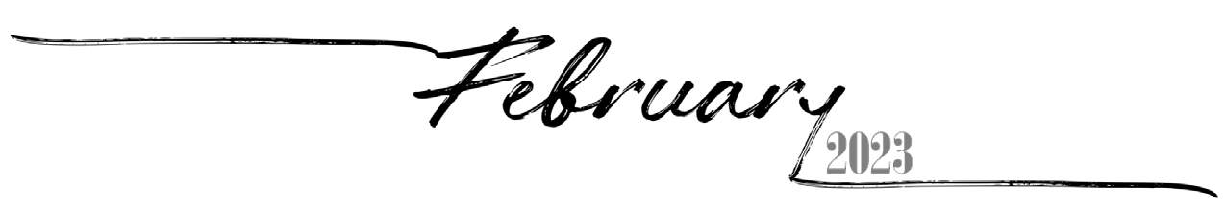

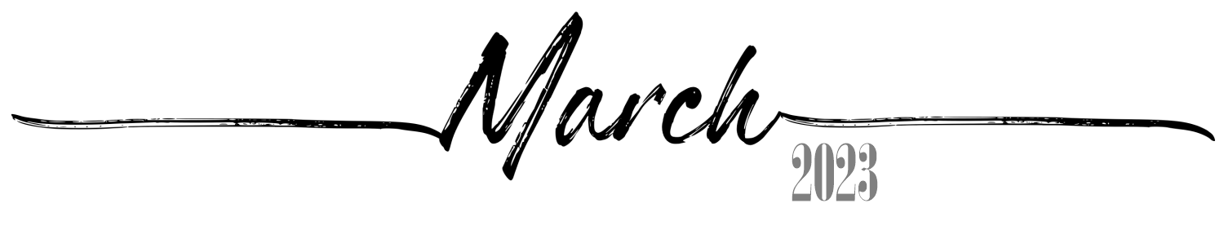

Sunday Monday Tuesday
 |  |  | 8th of Adar, 5783 | 9th of Adar, 5783 | 10th of Adar, 5783 | 11th of Adar, 5783
5 | 6 | 7 | 8 | 9 | 10 | 11
12th of Adar, 5783 | 13th of Adar, 5783 Erev Purim | 14th of Adar, 5783 Purim | 15th of Adar, 5783 Shushan Purim | 16th of Adar, 5783 | 17th of Adar, 5783 | 18th of Adar, 5783
12 | 13 | 14 | 15 | 16 | 17 | 18
19th of Adar, 5783 | 20th of Adar, 5783 | 21st of Adar, 5783 | 22nd of Adar, 5783 | 23rd of Adar, 5783 | 24th of Adar, 5783 | 25th of Adar, 5783
19 | 20 | 21 | 22 | 23 | 24 | 25
26th of Adar, 5783 | 27th of Adar, 5783 | 28th of Adar, 5783 | 29th of Adar, 5783 | 1st of Nisan, 5783 Rosh Chodesh Nisan | 2nd of Nisan, 5783 | 3rd of Nisan, 5783
26 | 27 | 28 | 29 | 30 | 31
4th of Nisan, 5783 | 5th of Nisan, 5783 | 6th of Nisan, 5783 | 7th of Nisan, 5783 | 8th of Nisan, 5783 | 9th of Nisan, 5783

Wednesday
1
Thursday
2
Friday
3
Saturday
4

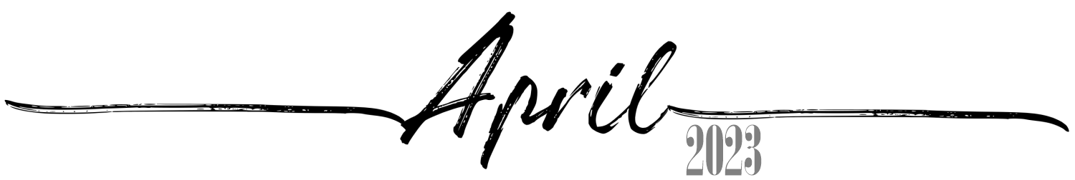
 |  |  |  |  |  | 1
 |  |  |  |  |  | 10th of Nisan, 5783 Yom HaAliyah
2 | 3 | 4 | 5 | 6 | 7 | 8
11th of Nisan, 5783 | 12th of Nisan, 5783 | 13th of Nisan, 5783 | 14th of Nisan, 5783 Erev Pesach | 15th of Nisan, 5783  Pesach I | 16th of Nisan, 5783  Pesach II | 17th of Nisan, 5783 Pesach III(CH''M)
9 | 10 | 11 | 12 | 13 | 14 | 15
18th ofNisan, 5783 Pesach IV(CH''M) | 19th of Nisan, 5783 Pesach V(CH''M) | 20th of Nisan, 5783 Pesach VI(CH''M) | 21st of Nisan, 5783  Pesach VII | 22nd of Nisan, 5783  Pesach VIII | 23rd of Nisan, 5783 | 24th of Nisan, 5783
16 | 17 | 18 | 19 | 20 | 21 | 22
25th of Nisan, 5783 | 26th of Nisan, 5783 | 27th of Nisan, 5783 Yom HaShoah | 28th of Nisan, 5783 | 29th of Nisan, 5783 | 30th of Nisan, 5783 Rosh ChodeshIyyar | 1st of Iyyar, 5783 Rosh ChodeshIyyar
23 | 24 | 25 | 26 | 27 | 28 | 29
2nd of Iyyar, 5783 | 3rd of Iyyar, 5783 | 4th of Iyyar, 5783 Yom HaZikaron | 5th of Iyyar, 5783 Yom HaAtzma'ut | 6th of Iyyar, 5783 | 7th of Iyyar, 5783 | 8th of Iyyar, 5783
30
9th of Iyyar, 5783

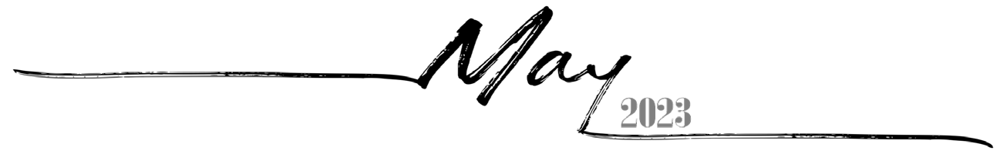
 | 1 | 2 | 3 | 4 | 5 | 6
 | 10th of Iyyar, 5783 | 11th of Iyyar, 5783 | 12th of Iyyar, 5783 | 13th of Iyyar, 5783 | 14th of Iyyar, 5783 Pesach Sheni | 15th of Iyyar, 5783
7 | 8 | 9 | 10 | 11 | 12 | 13
16th of Iyyar, 5783 | 17th of Iyyar, 5783 | 18th of Iyyar, 5783 Lag BaOmer | 19th of Iyyar, 5783 | 20th of Iyyar, 5783 | 21st of Iyyar, 5783 | 22nd of Iyyar, 5783
14 | 15 | 16 | 17 | 18 | 19 | 20
23rd of Iyyar, 5783 | 24th of Iyyar, 5783 | 25th of Iyyar, 5783 | 26th of Iyyar, 5783 | 27th of Iyyar, 5783 | 28th of Iyyar, 5783 YomYerushalayim | 29th of Iyyar, 5783
21 | 22 | 23 | 24 | 25 | 26 | 27
1st of Sivan, 5783 Rosh Chodesh Sivan | 2nd of Sivan, 5783 | 3rd of Sivan, 5783 | 4th of Sivan, 5783 | 5th of Sivan, 5783 Erev Shavuos | 6th of Sivan, 5783  Shavuos I | 7th of Sivan, 5783  Shavuos II
28 | 29 | 30 | 31
8th of Sivan, 5783 | 9th of Sivan, 5783 | 10th of Sivan, 5783 | 11th of Sivan, 5783

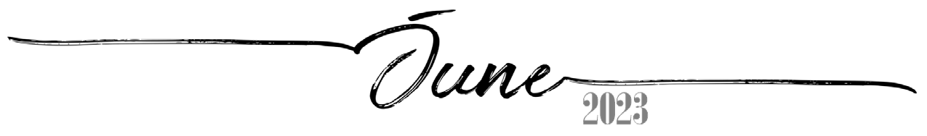
 |  |  |  | 1 | 2 | 3
 |  |  |  | 12th of Sivan, 5783 | 13th of Sivan, 5783 | 14th of Sivan, 5783
4 | 5 | 6 | 7 | 8 | 9 | 10
15th of Sivan, 5783 | 16th of Sivan, 5783 | 17th of Sivan, 5783 | 18th of Sivan, 5783 | 19th of Sivan, 5783 | 20th of Sivan, 5783 | 21st of Sivan, 5783
11 | 12 | 13 | 14 | 15 | 16 | 17
22nd of Sivan, 5783 | 23rd of Sivan, 5783 | 24th of Sivan, 5783 | 25th of Sivan, 5783 | 26th of Sivan, 5783 | 27th of Sivan, 5783 | 28th of Sivan, 5783
18 | 19 | 20 | 21 | 22 | 23 | 24
29th of Sivan, 5783 | 30th of Sivan, 5783 Rosh ChodeshTamuz | 1st of Tamuz, 5783 Rosh ChodeshTamuz | 2nd of Tamuz, 5783 | 3rd of Tamuz, 5783 | 4th of Tamuz, 5783 | 5th of Tamuz, 5783
25 | 26 | 27 | 28 | 29 | 30
6th of Tamuz, 5783 | 7th of Tamuz, 5783 | 8th of Tamuz, 5783 | 9th of Tamuz, 5783 | 10th of Tamuz, 5783 | 11th of Tamuz, 5783

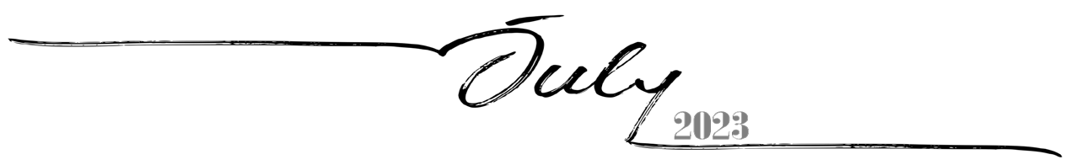
 |  |  |  |  |  | 1
 |  |  |  |  |  | 12th of Tamuz, 5783
2 | 3 | 4 | 5 | 6 | 7 | 8
13th of Tamuz, 5783 | 14th of Tamuz, 5783 | 15th of Tamuz, 5783 | 16th of Tamuz, 5783 | 17th of Tamuz, 5783 | 18th of Tamuz, 5783 | 19th of Tamuz, 5783
9 | 10 | 11 | 12 | 13 | 14 | 15
20th of Tamuz, 5783 | 21st of Tamuz, 5783 | 22nd of Tamuz, 5783 | 23rd of Tamuz, 5783 | 24th of Tamuz, 5783 | 25th of Tamuz, 5783 | 26th of Tamuz, 5783
16 | 17 | 18 | 19 | 20 | 21 | 22
27th of Tamuz, 5783 | 28th of Tamuz, 5783 | 29th of Tamuz, 5783 | 1st of Av, 5783 Rosh Chodesh Av | 2nd of Av, 5783 | 3rd of Av, 5783 | 4th of Av, 5783
23 | 24 | 25 | 26 | 27 | 28 | 29
5th of Av, 5783 | 6th of Av, 5783 | 7th of Av, 5783 | 8th of Av, 5783 Erev Tish'a B'Av | 9th of Av, 5783 Tish'a B'Av | 10th ofAv, 5783 | 11th ofAv, 5783
30 | 31
12th ofAv, 5783 | 13th ofAv, 5783

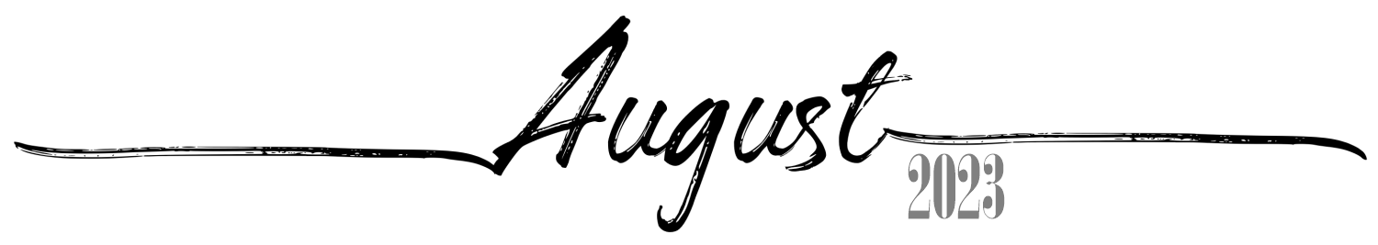
 |  | 1 | 2 | 3 | 4 | 5
 |  | 14th ofAv, 5783 | 15th of Av, 5783 Tu B'Av | 16th ofAv, 5783 | 17th ofAv, 5783 | 18th ofAv, 5783
6 | 7 | 8 | 9 | 10 | 11 | 12
19th ofAv, 5783 | 20th ofAv, 5783 | 21st ofAv, 5783 | 22nd ofAv, 5783 | 23rd ofAv, 5783 | 24th ofAv, 5783 | 25th ofAv, 5783
13 | 14 | 15 | 16 | 17 | 18 | 19
26th ofAv, 5783 | 27th ofAv, 5783 | 28th ofAv, 5783 | 29th ofAv, 5783 | 30th of Av, 5783 Rosh Chodesh Elul | 1st of Elul, 5783  Rosh HashanaLaBehemot  Rosh ChodeshElul | 2nd of Elul, 5783
20 | 21 | 22 | 23 | 24 | 25 | 26
3rd of Elul, 5783 | 4th of Elul, 5783 | 5th of Elul, 5783 | 6th of Elul, 5783 | 7th of Elul, 5783 | 8th of Elul, 5783 | 9th of Elul, 5783
27 | 28 | 29 | 30 | 31
10th of Elul, 5783 | 11th of Elul, 5783 | 12th of Elul, 5783 | 13th of Elul, 5783 | 14th of Elul, 5783

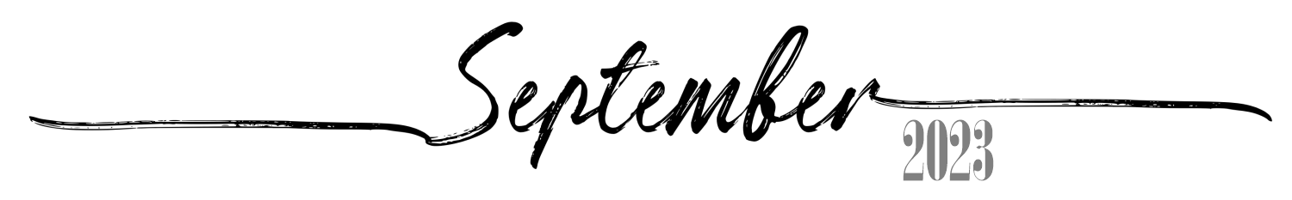
 |  |  |  |  | 1 | 2
 |  |  |  |  | 15th of Elul, 5783 | 16th of Elul, 5783
3 | 4 | 5 | 6 | 7 | 8 | 9
17th of Elul, 5783 | 18th of Elul, 5783 | 19th of Elul, 5783 | 20th of Elul, 5783 | 21st of Elul, 5783 | 22nd of Elul, 5783 | 23rd of Elul, 5783 Leil Selichos
10 | 11 | 12 | 13 | 14 | 15 | 16
24th of Elul, 5783 | 25th of Elul, 5783 | 26th of Elul, 5783 | 27th of Elul, 5783 | 28th of Elul, 5783 | 29th of Elul, 5783 Erev RoshHashana | 1st of Tishrei, 5784  Rosh Hashana5784
17 | 18 | 19 | 20 | 21 | 22 | 23
2nd of Tishrei, 5784  Rosh Hashana II | 3rd of Tishrei, 5784 | 4th of Tishrei, 5784 | 5th of Tishrei, 5784 | 6th of Tishrei, 5784 | 7th of Tishrei, 5784 | 8th of Tishrei, 5784
24 | 25 | 26 | 27 | 28 | 29 | 30
9th of Tishrei, 5784 Erev YomKippur | 10th of Tishrei, 5784  Yom Kippur | 11th of Tishrei, 5784 | 12th of Tishrei, 5784 | 13th of Tishrei, 5784 | 14th of Tishrei, 5784 Erev Sukkos | 15th of Tishrei, 5784  Sukkos I

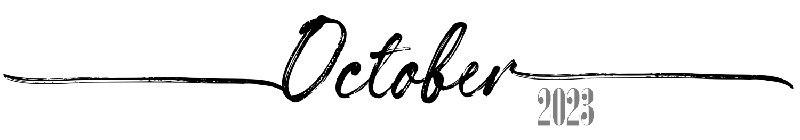
1  16th of Tishrei, 5784  Sukkos II | 2  17th of Tishrei, 5784 Sukkos III(CH''M) | 3  18th of Tishrei, 5784 Sukkos IV(CH''M) | 4  19th of Tishrei, 5784 Sukkos V(CH''M) | 5  20th of Tishrei, 5784 Sukkos VI(CH''M) | 6  21st of Tishrei, 5784  Sukkos VII (HoshanaRaba) | 7  22nd of Tishrei, 5784  Shmini Atzeres
8  23rd of Tishrei, 5784  Simchas Torah | 9  24th of Tishrei, 5784 | 10  25th of Tishrei, 5784 | 11  26th of Tishrei, 5784 | 12  27th of Tishrei, 5784 | 13  28th of Tishrei, 5784 | 14  29th of Tishrei, 5784
15  30th of Tishrei, 5784 Rosh ChodeshCheshvan | 16  1st of Cheshvan, 5784 Rosh ChodeshCheshvan | 17  2nd of Cheshvan, 5784 | 18  3rd of Cheshvan, 5784 | 19  4th of Cheshvan, 5784 | 20  5th of Cheshvan, 5784 | 21  6th of Cheshvan, 5784
22  7th of Cheshvan, 5784  Yom HaAliyah School Observance | 23  8th of Cheshvan, 5784 | 24  9th of Cheshvan, 5784 | 25  10th of Cheshvan, 5784 | 26  11th of Cheshvan, 5784 | 27  12th of Cheshvan, 5784 | 28  13th of Cheshvan, 5784
29  14th of Cheshvan, 5784 | 30  15th of Cheshvan, 5784 | 31  16th of Cheshvan, 5784

 |  |  |  |  |  | 17th of Cheshvan, 5784 | 1 | 18th of Cheshvan, 5784 | 2 | 19th of Cheshvan, 5784 | 3 | 20th of Cheshvan, 5784 | 4
21st of Cheshvan, 5784 | 5 | 22nd of Cheshvan, 5784 | 6 | 23rd of Cheshvan, 5784 | 7 | 24th of Cheshvan, 5784 | 8 | 25th of Cheshvan, 5784 | 9 | 26th of Cheshvan, 5784 | 10 | 27th of Cheshvan, 5784 | 11
28th of Cheshvan, 5784 | 12 | 29th of Cheshvan, 5784 Sigd | 13 | 1st of Kislev, 5784 Rosh ChodeshKislev | 14 | 2nd of Kislev, 5784 | 15 | 3rd of Kislev, 5784 | 16 | 4th of Kislev, 5784 | 17 | 5th of Kislev, 5784 | 18
6th of Kislev, 5784 | 19 | 7th of Kislev, 5784 | 20 | 8th of Kislev, 5784 | 21 | 9th of Kislev, 5784 | 22 | 10th of Kislev, 5784 | 23 | 11th of Kislev, 5784 | 24 | 12th of Kislev, 5784 | 25
13th of Kislev, 5784 | 26 | 14th of Kislev, 5784 | 27 | 15th of Kislev, 5784 | 28 | 16th of Kislev, 5784 | 29 | 17th of Kislev, 5784 | 30

 |  |  |  |  | 1  18th of Kislev, 5784 | 2  19th of Kislev, 5784
3  20th of Kislev, 5784 | 4  21st of Kislev, 5784 | 5  22nd of Kislev, 5784 | 6  23rd of Kislev, 5784 | 7  24th of Kislev, 5784 Chanukah: 1Candle | 8  25th of Kislev, 5784 Chanukah: 2Candles | 9  26th of Kislev, 5784 Chanukah: 3Candles
10  27th of Kislev, 5784 Chanukah: 4Candles | 11  28th of Kislev, 5784 Chanukah: 5Candles | 12  29th of Kislev, 5784 Chanukah: 6Candles | 13  1st of Tevet, 5784 Chanukah: 7Candles Rosh ChodeshTevet | 14  2nd of Tevet, 5784 Chanukah: 8Candles | 15  3rd of Tevet, 5784 Chanukah: 8thDay | 16  4th of Tevet, 5784
17  5th of Tevet, 5784 | 18  6th of Tevet, 5784 | 19  7th of Tevet, 5784 | 20  8th of Tevet, 5784 | 21  9th of Tevet, 5784 | 22  10th of Tevet, 5784 | 23  11th of Tevet, 5784
24  12th of Tevet, 5784 | 25  13th of Tevet, 5784 | 26  14th of Tevet, 5784 | 27  15th of Tevet, 5784 | 28  16th of Tevet, 5784 | 29  17th of Tevet, 5784 | 30  18th of Tevet, 5784
31
19th of Tevet, 5784

