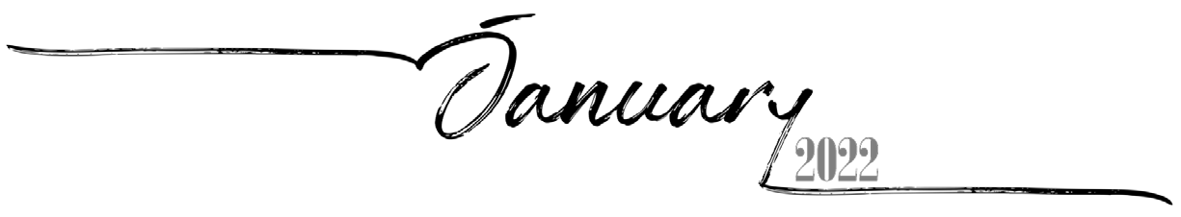
 |  |  |  |  |  | 1
 |  |  |  |  |  | 28th of Tevet, 5782
2 | 3 | 4 | 5 | 6 | 7 | 8
29th of Tevet, 5782 | 1st of Sh'vat, 5782 Rosh ChodeshSh'vat | 2nd of Sh'vat, 5782 | 3rd of Sh'vat, 5782 | 4th of Sh'vat, 5782 | 5th of Sh'vat, 5782 | 6th of Sh'vat, 5782
9 | 10 | 11 | 12 | 13 | 14 | 15
7th of Sh'vat, 5782 | 8th of Sh'vat, 5782 | 9th of Sh'vat, 5782 | 10th of Sh'vat, 5782 | 11th of Sh'vat, 5782 | 12th of Sh'vat, 5782 | 13th of Sh'vat, 5782
16 | 17 | 18 | 19 | 20 | 21 | 22
14th of Sh'vat, 5782 | 15th of Sh'vat, 5782 Tu BiShvat | 16th of Sh'vat, 5782 | 17th of Sh'vat, 5782 | 18th of Sh'vat, 5782 | 19th of Sh'vat, 5782 | 20th of Sh'vat, 5782
23 | 24 | 25 | 26 | 27 | 28 | 29
21st of Sh'vat, 5782 | 22nd of Sh'vat, 5782 | 23rd of Sh'vat, 5782 | 24th of Sh'vat, 5782 | 25th of Sh'vat, 5782 | 26th of Sh'vat, 5782 | 27th of Sh'vat, 5782
30 | 31
28th of Sh'vat, 5782 | 29th of Sh'vat, 5782

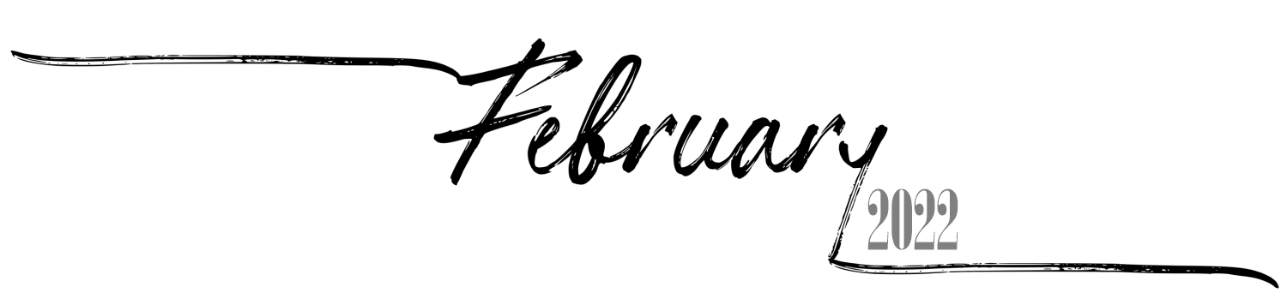

Sunday Monday Tuesday
Wednesday
Thursday Friday Saturday

 |  | 1 | 2 | 3 | 4 | 5
 |  | 30th of Sh'vat, 5782 Rosh Chodesh Adar I | 1st of Adar I, 5782 Rosh Chodesh Adar I | 2nd of Adar I, 5782 | 3rd of Adar I, 5782 | 4th of Adar I, 5782
6 | 7 | 8 | 9 | 10 | 11 | 12
5th of Adar I, 5782 | 6th of Adar I, 5782 | 7th of Adar I, 5782 | 8th of Adar I, 5782 | 9th of Adar I, 5782 | 10th of Adar I, 5782 | 11th of Adar I, 5782
13 | 14 | 15 | 16 | 17 | 18 | 19
12th of Adar I, 5782 | 13th of Adar I, 5782 | 14th of Adar I, 5782 Purim Koton | 15th of Adar I, 5782 | 16th of Adar I, 5782 | 17th of Adar I, 5782 | 18th of Adar I, 5782
20 | 21 | 22 | 23 | 24 | 25 | 26
19th of Adar I, 5782 | 20th of Adar I, 5782 | 21st of Adar I, 5782 | 22nd of Adar I, 5782 | 23rd of Adar I, 5782 | 24th of Adar I, 5782 | 25th of Adar I, 5782
27 | 28
26th of Adar I, 5782 | 27th of Adar I, 5782

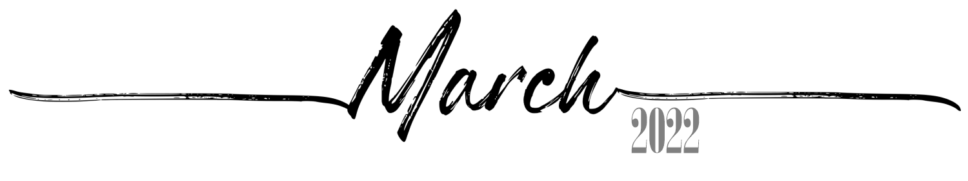
 |  | 1 | 2 | 3 | 4 | 5
 |  | 28th of Adar I, 5782 | 29th of Adar I, 5782 | 30th of Adar I, 5782 Rosh Chodesh Adar II | 1st of Adar II, 5782 Rosh Chodesh Adar II | 2nd of Adar II, 5782
6 | 7 | 8 | 9 | 10 | 11 | 12
3rd of Adar II, 5782 | 4th of Adar II, 5782 | 5th of Adar II, 5782 | 6th of Adar II, 5782 | 7th of Adar II, 5782 | 8th of Adar II, 5782 | 9th of Adar II, 5782
13 | 14 | 15 | 16 | 17 | 18 | 19
10th of Adar II, 5782 | 11th of Adar II, 5782 | 12th of Adar II, 5782 | 13th of Adar II,5782 Erev Purim | 14th of Adar II,5782 Purim | 15th of Adar II,5782 Shushan Purim | 16th of Adar II, 5782
20 | 21 | 22 | 23 | 24 | 25 | 26
17th of Adar II, 5782 | 18th of Adar II, 5782 | 19th of Adar II, 5782 | 20th of Adar II, 5782 | 21st of Adar II, 5782 | 22nd of Adar II, 5782 | 23rd of Adar II, 5782
27 | 28 | 29 | 30 | 31
24th of Adar II, 5782 | 25th of Adar II, 5782 | 26th of Adar II, 5782 | 27th of Adar II, 5782 | 28th of Adar II, 5782

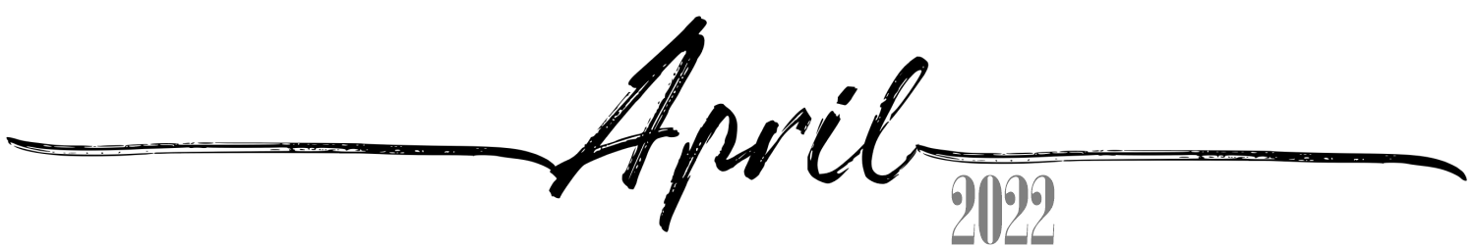
 |  |  |  |  | 1 | 2
 |  |  |  |  | 29th of Adar II, 5782 | 1st of Nisan, 5782 Rosh Chodesh Nisan
3 | 4 | 5 | 6 | 7 | 8 | 9
2nd of Nisan, 5782 | 3rd of Nisan, 5782 | 4th of Nisan, 5782 | 5th of Nisan, 5782 | 6th of Nisan, 5782 | 7th of Nisan, 5782 | 8th of Nisan, 5782
10 | 11 | 12 | 13 | 14 | 15 | 16
9th of Nisan, 5782 | 10th of Nisan, 5782 Yom HaAliyah | 11th of Nisan, 5782 | 12th of Nisan, 5782 | 13th of Nisan, 5782 | 14th of Nisan, 5782 Erev Pesach | 15th of Nisan, 5782  Pesach I
17 | 18 | 19 | 20 | 21 | 22 | 23
16th of Nisan, 5782  Pesach II | 17th of Nisan, 5782 Pesach III(CH''M) | 18th of Nisan, 5782 Pesach IV(CH''M) | 19th of Nisan, 5782 Pesach V(CH''M) | 20th of Nisan, 5782 Pesach VI(CH''M) | 21st of Nisan, 5782  Pesach VII | 22nd of Nisan, 5782  Pesach VIII
24 | 25 | 26 | 27 | 28 | 29 | 30
23rd of Nisan, 5782 | 24th of Nisan, 5782 | 25th of Nisan, 5782 | 26th of Nisan, 5782 | 27th of Nisan, 5782 Yom HaShoah | 28th of Nisan, 5782 | 29th of Nisan, 5782

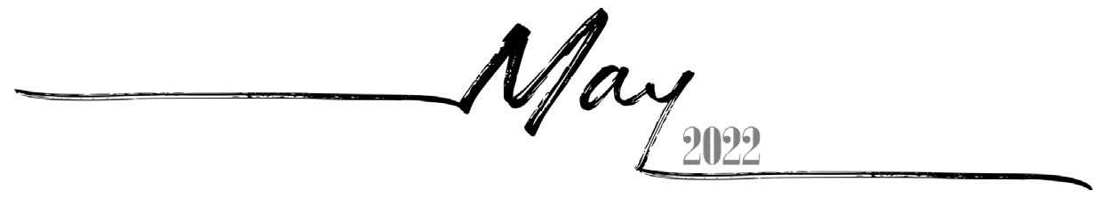
Sunday Monday Tuesday
Wednesday
Thursday Friday Saturday

1 | 2 | 3 | 4 | 5 | 6 | 7
30th of Nisan, 5782 Rosh ChodeshIyyar | 1st of Iyyar, 5782 Rosh ChodeshIyyar | 2nd of Iyyar, 5782 | 3rd of Iyyar, 5782 Yom HaZikaron | 4th of Iyyar, 5782 Yom HaAtzma'ut | 5th of Iyyar, 5782 | 6th of Iyyar, 5782
8 | 9 | 10 | 11 | 12 | 13 | 14
7th of Iyyar, 5782 | 8th of Iyyar, 5782 | 9th of Iyyar, 5782 | 10th of Iyyar, 5782 | 11th of Iyyar, 5782 | 12th of Iyyar, 5782 | 13th of Iyyar, 5782
15 | 16 | 17 | 18 | 19 | 20 | 21
14th of Iyyar, 5782 Pesach Sheni | 15th of Iyyar, 5782 | 16th of Iyyar, 5782 | 17th of Iyyar, 5782 | 18th of Iyyar, 5782 Lag BaOmer | 19th of Iyyar, 5782 | 20th of Iyyar, 5782
22 | 23 | 24 | 25 | 26 | 27 | 28
21st of Iyyar, 5782 | 22nd of Iyyar, 5782 | 23rd of Iyyar, 5782 | 24th of Iyyar, 5782 | 25th of Iyyar, 5782 | 26th of Iyyar, 5782 | 27th of Iyyar, 5782
29 | 30 | 31
28th of Iyyar, 5782 YomYerushalayim | 29th of Iyyar, 5782 | 1st of Sivan, 5782 Rosh Chodesh Sivan

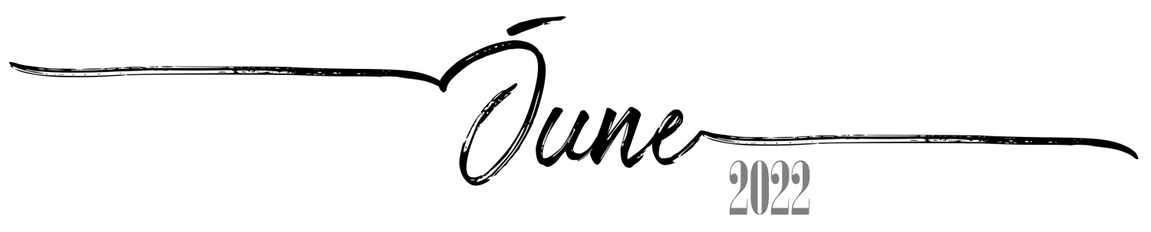

Sunday Monday Tuesday
Wednesday
Thursday Friday Saturday

 |  |  | 1 | 2 | 3 | 4
 |  |  | 2nd of Sivan, 5782 | 3rd of Sivan, 5782 | 4th of Sivan, 5782 | 5th of Sivan, 5782 Erev Shavuos
5 | 6 | 7 | 8 | 9 | 10 | 11
6th of Sivan, 5782  Shavuos I | 7th of Sivan, 5782  Shavuos II | 8th of Sivan, 5782 | 9th of Sivan, 5782 | 10th of Sivan, 5782 | 11th of Sivan, 5782 | 12th of Sivan, 5782
12 | 13 | 14 | 15 | 16 | 17 | 18
13th of Sivan, 5782 | 14th of Sivan, 5782 | 15th of Sivan, 5782 | 16th of Sivan, 5782 | 17th of Sivan, 5782 | 18th of Sivan, 5782 | 19th of Sivan, 5782
19 | 20 | 21 | 22 | 23 | 24 | 25
20th of Sivan, 5782 | 21st of Sivan, 5782 | 22nd of Sivan, 5782 | 23rd of Sivan, 5782 | 24th of Sivan, 5782 | 25th of Sivan, 5782 | 26th of Sivan, 5782
26 | 27 | 28 | 29 | 30
27th of Sivan, 5782 | 28th of Sivan, 5782 | 29th of Sivan, 5782 | 30th of Sivan, 5782 Rosh ChodeshTamuz | 1st of Tamuz, 5782 Rosh ChodeshTamuz

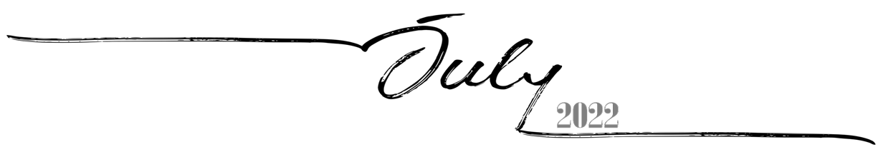
Sunday Monday Tuesday
Wednesday
Thursday Friday Saturday

 |  |  |  |  | 1 | 2
 |  |  |  |  | 2nd of Tamuz, 5782 | 3rd of Tamuz, 5782
3 | 4 | 5 | 6 | 7 | 8 | 9
4th of Tamuz, 5782 | 5th of Tamuz, 5782 | 6th of Tamuz, 5782 | 7th of Tamuz, 5782 | 8th of Tamuz, 5782 | 9th of Tamuz, 5782 | 10th of Tamuz, 5782
10 | 11 | 12 | 13 | 14 | 15 | 16
11th of Tamuz, 5782 | 12th of Tamuz, 5782 | 13th of Tamuz, 5782 | 14th of Tamuz, 5782 | 15th of Tamuz, 5782 | 16th of Tamuz, 5782 | 17th of Tamuz, 5782
17 | 18 | 19 | 20 | 21 | 22 | 23
18th of Tamuz, 5782 | 19th of Tamuz, 5782 | 20th of Tamuz, 5782 | 21st of Tamuz, 5782 | 22nd of Tamuz, 5782 | 23rd of Tamuz, 5782 | 24th of Tamuz, 5782
24 | 25 | 26 | 27 | 28 | 29 | 30
25th of Tamuz, 5782 | 26th of Tamuz, 5782 | 27th of Tamuz, 5782 | 28th of Tamuz, 5782 | 29th of Tamuz, 5782 | 1st of Av, 5782 Rosh Chodesh Av | 2nd of Av, 5782
31
3rd of Av, 5782

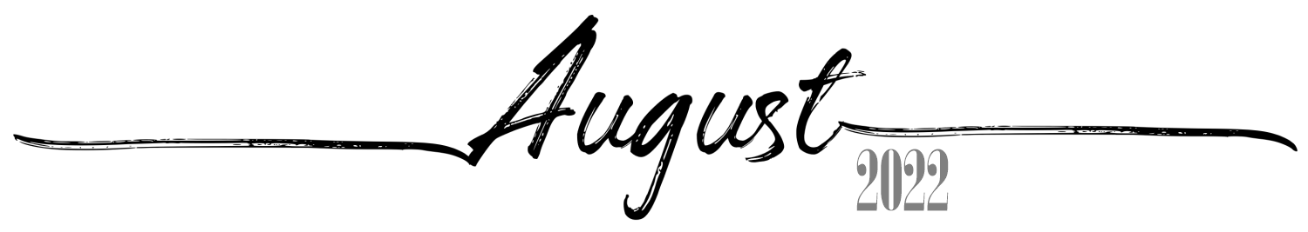
 | 1 | 2 | 3 | 4 | 5 | 6
 | 4th of Av, 5782 | 5th of Av, 5782 | 6th of Av, 5782 | 7th of Av, 5782 | 8th of Av, 5782 | 9th of Av, 5782 Erev Tish'a B'Av
7 | 8 | 9 | 10 | 11 | 12 | 13
10th of Av, 5782 Tish'a B'Av(observed) | 11th ofAv, 5782 | 12th of Av, 5782 | 13th of Av, 5782 | 14th of Av, 5782 | 15th of Av, 5782 Tu B'Av | 16th ofAv, 5782
14 | 15 | 16 | 17 | 18 | 19 | 20
17th ofAv, 5782 | 18th ofAv, 5782 | 19th of Av, 5782 | 20th of Av, 5782 | 21st ofAv, 5782 | 22nd of Av, 5782 | 23rd of Av, 5782
21 | 22 | 23 | 24 | 25 | 26 | 27
24th ofAv, 5782 | 25th ofAv, 5782 | 26th of Av, 5782 | 27th of Av, 5782 | 28th of Av, 5782 | 29th of Av, 5782 | 30th of Av, 5782 Rosh Chodesh Elul
28 | 29 | 30 | 31
1st of Elul, 5782  Rosh HashanaLaBehemot  Rosh ChodeshElul | 2nd of Elul, 5782 | 3rd of Elul, 5782 | 4th of Elul, 5782

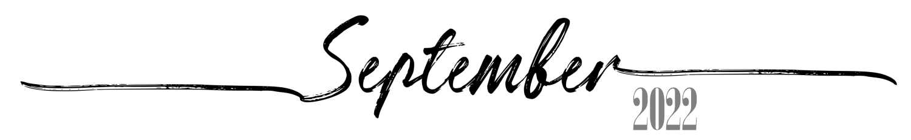
 |  |  |  | 1 | 2 | 3
 |  |  |  | 5th of Elul, 5782 | 6th of Elul, 5782 | 7th of Elul, 5782
4 | 5 | 6 | 7 | 8 | 9 | 10
8th of Elul, 5782 | 9th of Elul, 5782 | 10th of Elul, 5782 | 11th of Elul, 5782 | 12th of Elul, 5782 | 13th of Elul, 5782 | 14th of Elul, 5782
11 | 12 | 13 | 14 | 15 | 16 | 17
15th of Elul, 5782 | 16th of Elul, 5782 | 17th of Elul, 5782 | 18th of Elul, 5782 | 19th of Elul, 5782 | 20th of Elul, 5782 | 21st of Elul, 5782 Leil Selichos
18 | 19 | 20 | 21 | 22 | 23 | 24
22nd of Elul, 5782 | 23rd of Elul, 5782 | 24th of Elul, 5782 | 25th of Elul, 5782 | 26th of Elul, 5782 | 27th of Elul, 5782 | 28th of Elul, 5782
25 | 26 | 27 | 28 | 29 | 30
29th of Elul, 5782 Erev RoshHashana | 1st of Tishrei, 5783  Rosh Hashana5783 | 2nd of Tishrei, 5783  Rosh Hashana II | 3rd of Tishrei, 5783 | 4th of Tishrei, 5783 | 5th of Tishrei, 5783

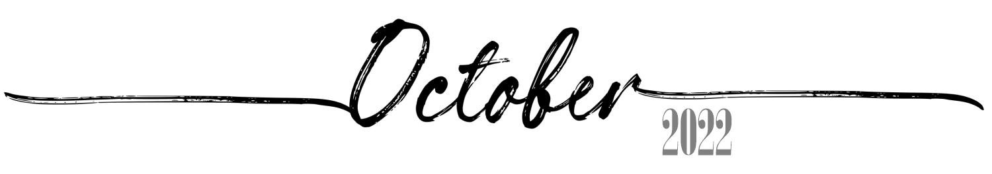
 |  |  |  |  |  | 1
 |  |  |  |  |  | 6th of Tishrei, 5783
2 | 3 | 4  9th of Tishrei, 5783 Erev YomKippur | 5  10th of Tishrei, 5783  Yom Kippur | 6 | 7 | 8
7th of Tishrei, 5783 | 8th of Tishrei, 5783 |  |  | 11th of Tishrei, 5783 | 12th of Tishrei, 5783 | 13th of Tishrei, 5783
9 | 10 | 11  16th of Tishrei, 5783  Sukkos II | 12  17th of Tishrei, 5783 Sukkos III(CH''M) | 13 | 14 | 15
14th of Tishrei, 5783 Erev Sukkos | 15th of Tishrei, 5783  Sukkos I |  |  | 18th of Tishrei, 5783 Sukkos IV(CH''M) | 19th of Tishrei, 5783 Sukkos V(CH''M) | 20th of Tishrei, 5783 Sukkos VI(CH''M)
16 | 17 | 18  23rd of Tishrei, 5783  Simchas Torah | 19  24th of Tishrei, 5783 | 20 | 21 | 22
21st of Tishrei, 5783  Sukkos VII (HoshanaRaba) | 22nd of Tishrei, 5783  Shmini Atzeres |  |  | 25th of Tishrei, 5783 | 26th of Tishrei, 5783 | 27th of Tishrei, 5783
23 | 24 | 25  30th of Tishrei, 5783 Rosh ChodeshCheshvan | 26  1st of Cheshvan, 5783 Rosh ChodeshCheshvan | 27 | 28 | 29
28th of Tishrei, 5783 | 29th of Tishrei, 5783 |  |  | 2nd of Cheshvan, 5783 | 3rd of Cheshvan, 5783 | 4th of Cheshvan, 5783
30 | 31
5th of Cheshvan, 5783 | 6th of Cheshvan, 5783

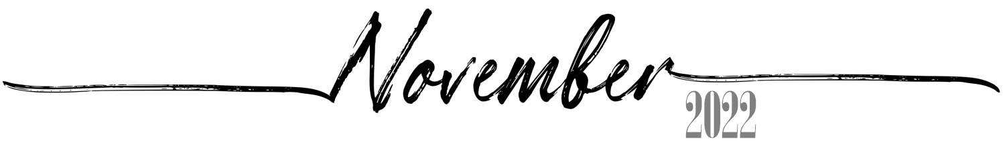
 |  | 1  7th of Cheshvan, 5783  Yom HaAliyah School Observance | 2 | 3 | 4 | 5
 |  |  | 8th of Cheshvan, 5783 | 9th of Cheshvan, 5783 | 10th of Cheshvan, 5783 | 11th of Cheshvan, 5783
6 | 7 | 8 | 9 | 10 | 11 | 12
12th of Cheshvan, 5783 | 13th of Cheshvan, 5783 | 14th of Cheshvan, 5783 | 15th of Cheshvan, 5783 | 16th of Cheshvan, 5783 | 17th of Cheshvan, 5783 | 18th of Cheshvan, 5783
13 | 14 | 15 | 16 | 17 | 18 | 19
19th of Cheshvan, 5783 | 20th of Cheshvan, 5783 | 21st of Cheshvan, 5783 | 22nd of Cheshvan, 5783 | 23rd of Cheshvan, 5783 | 24th of Cheshvan, 5783 | 25th of Cheshvan, 5783
20 | 21 | 22 | 23 | 24 | 25 | 26
26th of Cheshvan, 5783 | 27th of Cheshvan, 5783 | 28th of Cheshvan, 5783 | 29th of Cheshvan, 5783 Sigd | 30th of Cheshvan, 5783 Rosh ChodeshKislev | 1st of Kislev, 5783 Rosh ChodeshKislev | 2nd of Kislev, 5783
27 | 28 | 29 | 30
3rd of Kislev, 5783 | 4th of Kislev, 5783 | 5th of Kislev, 5783 | 6th of Kislev, 5783

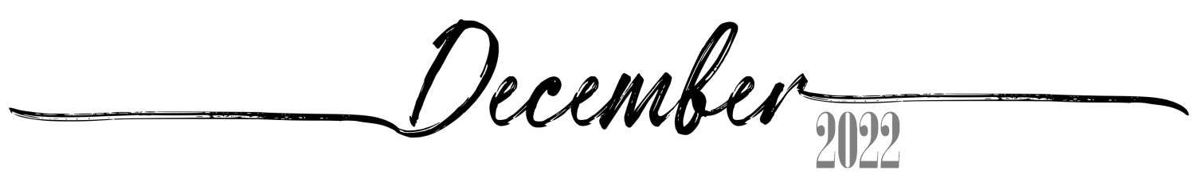
 |  |  |  | 1  7th of Kislev, 5783 | 2  8th of Kislev, 5783 | 3  9th of Kislev, 5783
4  10th of Kislev, 5783 | 5  11th of Kislev, 5783 | 6  12th of Kislev, 5783 | 7  13th of Kislev, 5783 | 8  14th of Kislev, 5783 | 9  15th of Kislev, 5783 | 10  16th of Kislev, 5783
11  17th of Kislev, 5783 | 12  18th of Kislev, 5783 | 13  19th of Kislev, 5783 | 14  20th of Kislev, 5783 | 15  21st of Kislev, 5783 | 16  22nd of Kislev, 5783 | 17  23rd of Kislev, 5783
18  24th of Kislev, 5783 Chanukah:1 Candle | 19  25th of Kislev, 5783 Chanukah: 2Candles | 20  26th of Kislev, 5783 Chanukah: 3Candles | 21  27th of Kislev, 5783 Chanukah: 4Candles | 22  28th of Kislev, 5783 Chanukah: 5Candles | 23  29th of Kislev, 5783 Chanukah: 6Candles | 24  30th of Kislev, 5783 Chanukah: 7Candles Rosh ChodeshTevet
25  1st of Tevet, 5783 Chanukah: 8Candles Rosh ChodeshTevet | 26  2nd of Tevet, 5783 Chanukah: 8thDay | 27  3rd of Tevet, 5783 | 28  4th of Tevet, 5783 | 29  5th of Tevet, 5783 | 30  6th of Tevet, 5783 | 31  7th of Tevet, 5783

