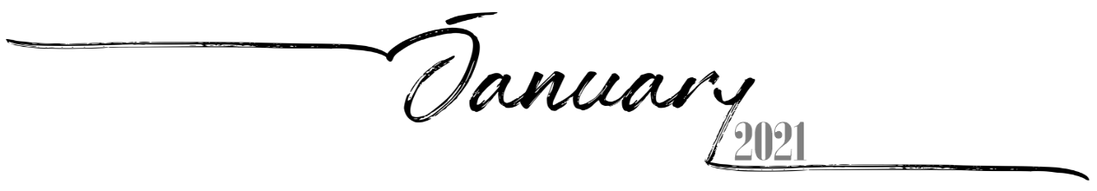
 |  |  |  |  | 1 | 2
 |  |  |  |  | 17th of Tevet, 5781 | 18th of Tevet, 5781
3 | 4 | 5 | 6 | 7 | 8 | 9
19th of Tevet, 5781 | 20th of Tevet, 5781 | 21st of Tevet, 5781 | 22nd of Tevet, 5781 | 23rd of Tevet, 5781 | 24th of Tevet, 5781 | 25th of Tevet, 5781
10 | 11 | 12 | 13 | 14 | 15 | 16
26th of Tevet, 5781 | 27th of Tevet, 5781 | 28th of Tevet, 5781 | 29th of Tevet, 5781 | 1st of Sh'vat, 5781 Rosh ChodeshSh'vat | 2nd of Sh'vat, 5781 | 3rd of Sh'vat, 5781
17 | 18 | 19 | 20 | 21 | 22 | 23
4th of Sh'vat, 5781 | 5th of Sh'vat, 5781 | 6th of Sh'vat, 5781 | 7th of Sh'vat, 5781 | 8th of Sh'vat, 5781 | 9th of Sh'vat, 5781 | 10th of Sh'vat, 5781
24 | 25 | 26 | 27 | 28 | 29 | 30
11th of Sh'vat, 5781 | 12th of Sh'vat, 5781 | 13th of Sh'vat, 5781 | 14th of Sh'vat, 5781 | 15th of Sh'vat, 5781 Tu BiShvat | 16th of Sh'vat, 5781 | 17th of Sh'vat, 5781
31
18th of Sh'vat, 5781

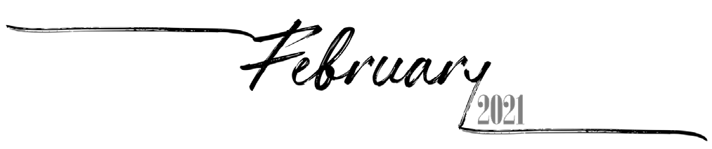
 | 1 | 2 | 3 | 4 | 5 | 6
 | 19th of Sh'vat, 5781 | 20th of Sh'vat, 5781 | 21st of Sh'vat, 5781 | 22nd of Sh'vat, 5781 | 23rd of Sh'vat, 5781 | 24th of Sh'vat, 5781
7 | 8 | 9 | 10 | 11 | 12 | 13
25th of Sh'vat, 5781 | 26th of Sh'vat, 5781 | 27th of Sh'vat, 5781 | 28th of Sh'vat, 5781 | 29th of Sh'vat, 5781 | 30th of Sh'vat, 5781 Rosh ChodeshAdar | 1st of Adar, 5781 Rosh Chodesh Adar
14 | 15 | 16 | 17 | 18 | 19 | 20
2nd of Adar, 5781 | 3rd of Adar, 5781 | 4th of Adar, 5781 | 5th of Adar, 5781 | 6th of Adar, 5781 | 7th of Adar, 5781 | 8th of Adar, 5781
21 | 22 | 23 | 24 | 25 | 26 | 27
9th of Adar, 5781 | 10th of Adar, 5781 | 11th of Adar, 5781 | 12th of Adar, 5781 | 13th of Adar, 5781 Erev Purim | 14th of Adar, 5781 Purim | 15th of Adar, 5781
28
16th of Adar, 5781 Shushan Purim

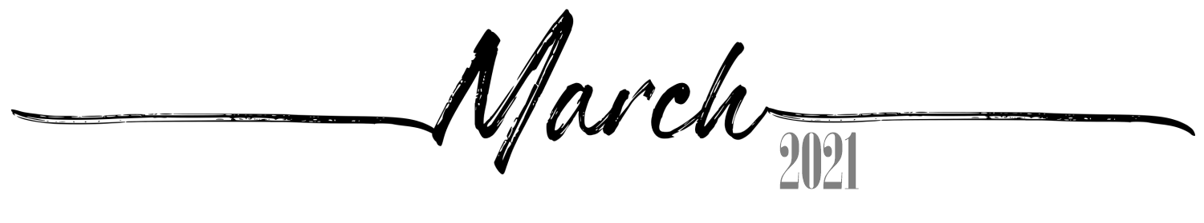
 | 1 | 2 | 3 | 4 | 5 | 6
 | 17th of Adar, 5781 | 18th of Adar, 5781 | 19th of Adar, 5781 | 20th of Adar, 5781 | 21st of Adar, 5781 | 22nd of Adar, 5781
7 | 8 | 9 | 10 | 11 | 12 | 13
23rd of Adar, 5781 | 24th of Adar, 5781 | 25th of Adar, 5781 | 26th of Adar, 5781 | 27th of Adar, 5781 | 28th of Adar, 5781 | 29th of Adar, 5781
14 | 15 | 16 | 17 | 18 | 19 | 20
1st of Nisan, 5781 Rosh Chodesh Nisan | 2nd of Nisan, 5781 | 3rd of Nisan, 5781 | 4th of Nisan, 5781 | 5th of Nisan, 5781 | 6th of Nisan, 5781 | 7th of Nisan, 5781
21 | 22 | 23 | 24 | 25 | 26 | 27
8th of Nisan, 5781 | 9th of Nisan, 5781 | 10th of Nisan, 5781 Yom HaAliyah | 11th of Nisan, 5781 | 12th of Nisan, 5781 | 13th of Nisan, 5781 | 14th of Nisan, 5781 Erev Pesach
28 | 29 | 30 | 31
15th of Nisan, 5781  Pesach I | 16th of Nisan, 5781  Pesach II | 17th of Nisan, 5781 Pesach III(CH''M) | 18th of Nisan, 5781 Pesach IV(CH''M)

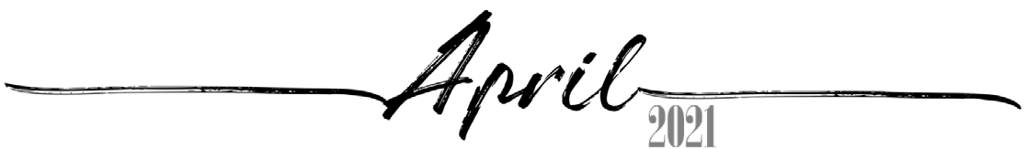
 |  |  |  | 1 | 2 | 3
 |  |  |  | 19th of Nisan, 5781 Pesach V(CH''M) | 20th of Nisan, 5781 Pesach VI(CH''M) | 21st of Nisan, 5781  Pesach VII
4 | 5 | 6 | 7 | 8 | 9 | 10
22nd of Nisan, 5781  Pesach VIII | 23rd of Nisan, 5781 | 24th of Nisan, 5781 | 25th of Nisan, 5781 | 26th of Nisan, 5781 Yom HaShoah | 27th of Nisan, 5781 | 28th of Nisan, 5781
11 | 12 | 13 | 14 | 15 | 16 | 17
29th of Nisan, 5781 | 30th of Nisan, 5781 Rosh ChodeshIyyar | 1st of Iyyar, 5781 Rosh ChodeshIyyar | 2nd of Iyyar, 5781 Yom HaZikaron | 3rd of Iyyar, 5781 Yom HaAtzma'ut | 4th of Iyyar, 5781 | 5th of Iyyar, 5781
18 | 19 | 20 | 21 | 22 | 23 | 24
6th of Iyyar, 5781 | 7th of Iyyar, 5781 | 8th of Iyyar, 5781 | 9th of Iyyar, 5781 | 10th of Iyyar, 5781 | 11th of Iyyar, 5781 | 12th of Iyyar, 5781
25 | 26 | 27 | 28 | 29 | 30
13th of Iyyar, 5781 | 14th of Iyyar, 5781 Pesach Sheni | 15th of Iyyar, 5781 | 16th of Iyyar, 5781 | 17th of Iyyar, 5781 | 18th of Iyyar, 5781 Lag BaOmer

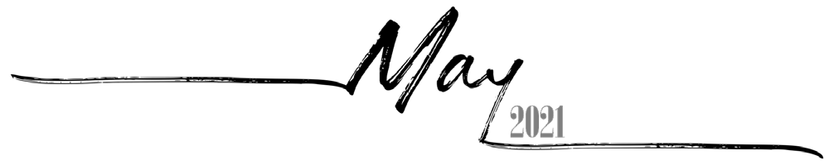
 |  |  |  |  |  | 1
 |  |  |  |  |  | 19th of Iyyar, 5781
2 | 3 | 4 | 5 | 6 | 7 | 8
20th of Iyyar, 5781 | 21st of Iyyar, 5781 | 22nd of Iyyar, 5781 | 23rd of Iyyar, 5781 | 24th of Iyyar, 5781 | 25th of Iyyar, 5781 | 26th of Iyyar, 5781
9 | 10 | 11 | 12 | 13 | 14 | 15
27th of Iyyar, 5781 | 28th of Iyyar, 5781 YomYerushalayim | 29th of Iyyar, 5781 | 1st of Sivan, 5781 Rosh Chodesh Sivan | 2nd of Sivan, 5781 | 3rd of Sivan, 5781 | 4th of Sivan, 5781
16 | 17 | 18 | 19 | 20 | 21 | 22
5th of Sivan, 5781 Erev Shavuos | 6th of Sivan, 5781  Shavuos I | 7th of Sivan, 5781  Shavuos II | 8th of Sivan, 5781 | 9th of Sivan, 5781 | 10th of Sivan, 5781 | 11th of Sivan, 5781
23 | 24 | 25 | 26 | 27 | 28 | 29
12th of Sivan, 5781 | 13th of Sivan, 5781 | 14th of Sivan, 5781 | 15th of Sivan, 5781 | 16th of Sivan, 5781 | 17th of Sivan, 5781 | 18th of Sivan, 5781
30 | 31
19th of Sivan, 5781 | 20th of Sivan, 5781

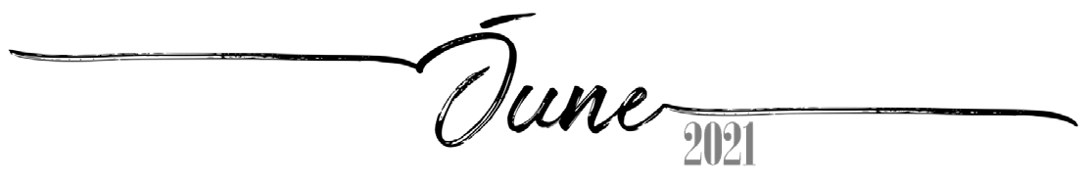
 |  | 1 | 2 | 3 | 4 | 5
 |  | 21st of Sivan, 5781 | 22nd of Sivan, 5781 | 23rd of Sivan, 5781 | 24th of Sivan, 5781 | 25th of Sivan, 5781
6 | 7 | 8 | 9 | 10 | 11 | 12
26th of Sivan, 5781 | 27th of Sivan, 5781 | 28th of Sivan, 5781 | 29th of Sivan, 5781 | 30th of Sivan, 5781 Rosh ChodeshTamuz | 1st of Tamuz, 5781 Rosh ChodeshTamuz | 2nd of Tamuz, 5781
13 | 14 | 15 | 16 | 17 | 18 | 19
3rd of Tamuz, 5781 | 4th of Tamuz, 5781 | 5th of Tamuz, 5781 | 6th of Tamuz, 5781 | 7th of Tamuz, 5781 | 8th of Tamuz, 5781 | 9th of Tamuz, 5781
20 | 21 | 22 | 23 | 24 | 25 | 26
10th of Tamuz, 5781 | 11th of Tamuz, 5781 | 12th of Tamuz, 5781 | 13th of Tamuz, 5781 | 14th of Tamuz, 5781 | 15th of Tamuz, 5781 | 16th of Tamuz, 5781
27 | 28 | 29 | 30
17th of Tamuz, 5781 | 18th of Tamuz, 5781 | 19th of Tamuz, 5781 | 20th of Tamuz, 5781

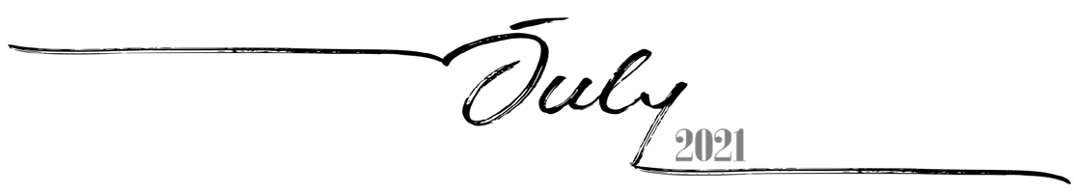
 |  |  |  | 1 | 2 | 3
 |  |  |  | 21st of Tamuz, 5781 | 22nd of Tamuz, 5781 | 23rd of Tamuz, 5781
4 | 5 | 6 | 7 | 8 | 9 | 10
24th of Tamuz, 5781 | 25th of Tamuz, 5781 | 26th of Tamuz, 5781 | 27th of Tamuz, 5781 | 28th of Tamuz, 5781 | 29th of Tamuz, 5781 | 1st of Av, 5781 Rosh Chodesh Av
11 | 12 | 13 | 14 | 15 | 16 | 17
2nd of Av, 5781 | 3rd of Av, 5781 | 4th of Av, 5781 | 5th of Av, 5781 | 6th of Av, 5781 | 7th of Av, 5781 | 8th of Av, 5781 Erev Tish'a B'Av
18 | 19 | 20 | 21 | 22 | 23 | 24
9th of Av, 5781 Tish'a B'Av | 10th ofAv, 5781 | 11th ofAv, 5781 | 12th ofAv, 5781 | 13th ofAv, 5781 | 14th ofAv, 5781 | 15th of Av, 5781 Tu B'Av
25 | 26 | 27 | 28 | 29 | 30 | 31
16th ofAv, 5781 | 17th ofAv, 5781 | 18th ofAv, 5781 | 19th ofAv, 5781 | 20th ofAv, 5781 | 21st ofAv, 5781 | 22nd ofAv, 5781

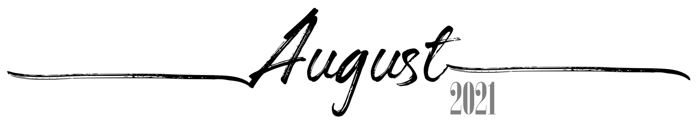
1 | 2 | 3 | 4 | 5 | 6 | 7
23rd ofAv, 5781 | 24th ofAv, 5781 | 25th ofAv, 5781 | 26th ofAv, 5781 | 27th ofAv, 5781 | 28th ofAv, 5781 | 29th ofAv, 5781
8 | 9 | 10 | 11 | 12 | 13 | 14
30th of Av, 5781 Rosh Chodesh Elul | 1st of Elul, 5781  Rosh HashanaLaBehemot  Rosh ChodeshElul | 2nd of Elul, 5781 | 3rd of Elul, 5781 | 4th of Elul, 5781 | 5th of Elul, 5781 | 6th of Elul, 5781
15 | 16 | 17 | 18 | 19 | 20 | 21
7th of Elul, 5781 | 8th of Elul, 5781 | 9th of Elul, 5781 | 10th of Elul, 5781 | 11th of Elul, 5781 | 12th of Elul, 5781 | 13th of Elul, 5781
22 | 23 | 24 | 25 | 26 | 27 | 28
14th of Elul, 5781 | 15th of Elul, 5781 | 16th of Elul, 5781 | 17th of Elul, 5781 | 18th of Elul, 5781 | 19th of Elul, 5781 | 20th of Elul, 5781 Leil Selichos
29 | 30 | 31
21st of Elul, 5781 | 22nd of Elul, 5781 | 23rd of Elul, 5781

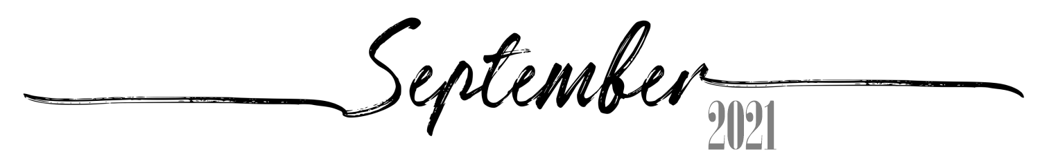
 |  |  | 1 | 2 | 3 | 4
 |  |  | 24th of Elul, 5781 | 25th of Elul, 5781 | 26th of Elul, 5781 | 27th of Elul, 5781
5 | 6 | 7 | 8 | 9 | 10 | 11
28th of Elul, 5781 | 29th of Elul, 5781 Erev RoshHashana | 1st of Tishrei, 5782  Rosh Hashana5782 | 2nd of Tishrei, 5782  Rosh Hashana II | 3rd of Tishrei, 5782 | 4th of Tishrei, 5782 | 5th of Tishrei, 5782
12 | 13 | 14 | 15 | 16 | 17 | 18
6th of Tishrei, 5782 | 7th of Tishrei, 5782 | 8th of Tishrei, 5782 | 9th of Tishrei, 5782 Erev YomKippur | 10th of Tishrei, 5782  Yom Kippur | 11th of Tishrei, 5782 | 12th of Tishrei, 5782
19 | 20 | 21 | 22 | 23 | 24 | 25
13th of Tishrei, 5782 | 14th of Tishrei, 5782 Erev Sukkos | 15th of Tishrei, 5782  Sukkos I | 16th of Tishrei, 5782  Sukkos II | 17th of Tishrei, 5782 Sukkos III(CH''M) | 18th of Tishrei, 5782 Sukkos IV(CH''M) | 19th of Tishrei, 5782 Sukkos V(CH''M)
26 | 27 | 28 | 29 | 30
20th of Tishrei, 5782 Sukkos VI(CH''M) | 21st of Tishrei, 5782  Sukkos VII (HoshanaRaba) | 22nd of Tishrei, 5782  Shmini Atzeres | 23rd of Tishrei, 5782  Simchas Torah | 24th of Tishrei, 5782

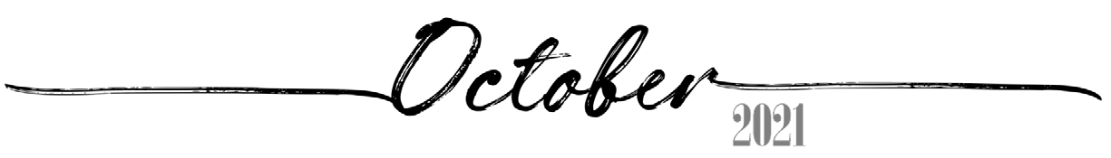
 |  |  |  |  | 1 | 2
 |  |  |  |  | 25th of Tishrei, 5782 | 26th of Tishrei, 5782
3 | 4 | 5 | 6 | 7 | 8 | 9
27th of Tishrei, 5782 | 28th of Tishrei, 5782 | 29th of Tishrei, 5782 | 30th of Tishrei, 5782 Rosh ChodeshCheshvan | 1st of Cheshvan, 5782 Rosh ChodeshCheshvan | 2nd of Cheshvan, 5782 | 3rd of Cheshvan, 5782
10 | 11 | 12 | 13  7th of Cheshvan, 5782  Yom HaAliyah School Observance | 14 | 15 | 16
4th of Cheshvan, 5782 | 5th of Cheshvan, 5782 | 6th of Cheshvan, 5782 |  | 8th of Cheshvan, 5782 | 9th of Cheshvan, 5782 | 10th of Cheshvan, 5782
17 | 18 | 19 | 20 | 21 | 22 | 23
11th of Cheshvan, 5782 | 12th of Cheshvan, 5782 | 13th of Cheshvan, 5782 | 14th of Cheshvan, 5782 | 15th of Cheshvan, 5782 | 16th of Cheshvan, 5782 | 17th of Cheshvan, 5782
24 | 25 | 26 | 27 | 28 | 29 | 30
18th of Cheshvan, 5782 | 19th of Cheshvan, 5782 | 20th of Cheshvan, 5782 | 21st of Cheshvan, 5782 | 22nd of Cheshvan, 5782 | 23rd of Cheshvan, 5782 | 24th of Cheshvan, 5782
31
25th of Cheshvan, 5782

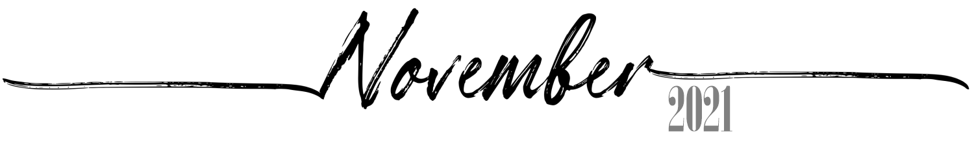
 | 1 | 2 | 3 | 4 | 5 | 6
 | 26th of Cheshvan, 5782 | 27th of Cheshvan, 5782 | 28th of Cheshvan, 5782 | 29th of Cheshvan, 5782 Sigd | 1st of Kislev, 5782 Rosh ChodeshKislev | 2nd of Kislev, 5782
7 | 8 | 9 | 10 | 11 | 12 | 13
3rd of Kislev, 5782 | 4th of Kislev, 5782 | 5th of Kislev, 5782 | 6th of Kislev, 5782 | 7th of Kislev, 5782 | 8th of Kislev, 5782 | 9th of Kislev, 5782
14 | 15 | 16 | 17 | 18 | 19 | 20
10th of Kislev, 5782 | 11th of Kislev, 5782 | 12th of Kislev, 5782 | 13th of Kislev, 5782 | 14th of Kislev, 5782 | 15th of Kislev, 5782 | 16th of Kislev, 5782
21 | 22 | 23 | 24 | 25 | 26 | 27
17th of Kislev, 5782 | 18th of Kislev, 5782 | 19th of Kislev, 5782 | 20th of Kislev, 5782 | 21st of Kislev, 5782 | 22nd of Kislev, 5782 | 23rd of Kislev, 5782
28 | 29 | 30
24th of Kislev, 5782 Chanukah:1 Candle | 25th of Kislev, 5782 Chanukah: 2Candles | 26th of Kislev, 5782 Chanukah: 3Candles

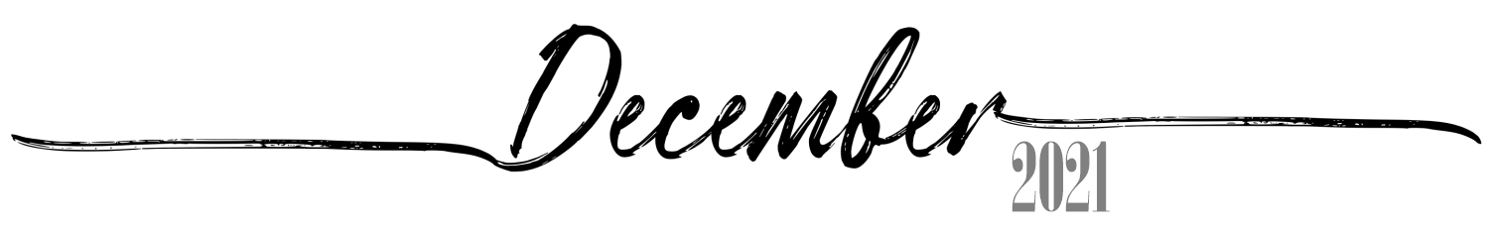
 |  |  | 1 | 2 | 3 | 4
 |  |  | 27th of Kislev, 5782 Chanukah: 4Candles | 28th of Kislev, 5782 Chanukah: 5Candles | 29th of Kislev, 5782 Chanukah: 6Candles | 30th of Kislev, 5782 Chanukah: 7Candles Rosh ChodeshTevet
5 | 6 | 7 | 8 | 9 | 10 | 11
1st of Tevet, 5782 Chanukah: 8Candles Rosh ChodeshTevet | 2nd of Tevet, 5782 Chanukah: 8thDay | 3rd of Tevet, 5782 | 4th of Tevet, 5782 | 5th of Tevet, 5782 | 6th of Tevet, 5782 | 7th of Tevet, 5782
12 | 13 | 14 | 15 | 16 | 17 | 18
8th of Tevet, 5782 | 9th of Tevet, 5782 | 10th of Tevet, 5782 | 11th of Tevet, 5782 | 12th of Tevet, 5782 | 13th of Tevet, 5782 | 14th of Tevet, 5782
19 | 20 | 21 | 22 | 23 | 24 | 25
15th of Tevet, 5782 | 16th of Tevet, 5782 | 17th of Tevet, 5782 | 18th of Tevet, 5782 | 19th of Tevet, 5782 | 20th of Tevet, 5782 | 21st of Tevet, 5782
26 | 27 | 28 | 29 | 30 | 31
22nd of Tevet, 5782 | 23rd of Tevet, 5782 | 24th of Tevet, 5782 | 25th of Tevet, 5782 | 26th of Tevet, 5782 | 27th of Tevet, 5782

