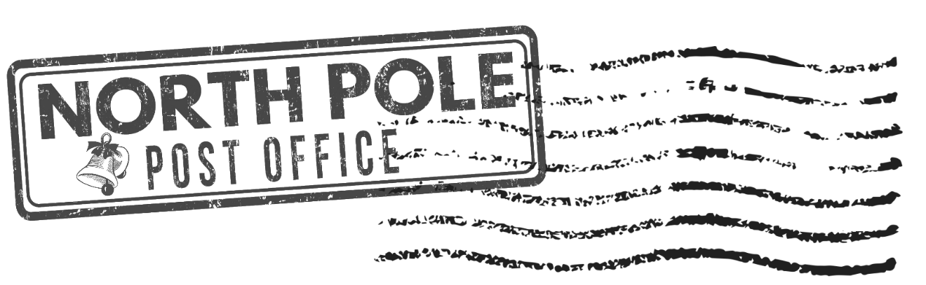

Dear Santa,

My name is:

My address is:

I am a:

* Girl
* Boy

I live with:

I am years old.

This year I have been:

* Naughty (but I can explain: )
* Nice
* A bit of both

Next year, I promise to:

For Christmas this year I am hoping to get:

* Something I want
* Something I need
* Something to wear
* Something to read

Have a safe trip on Christmas Eve!

Happy Christmas!

Love,