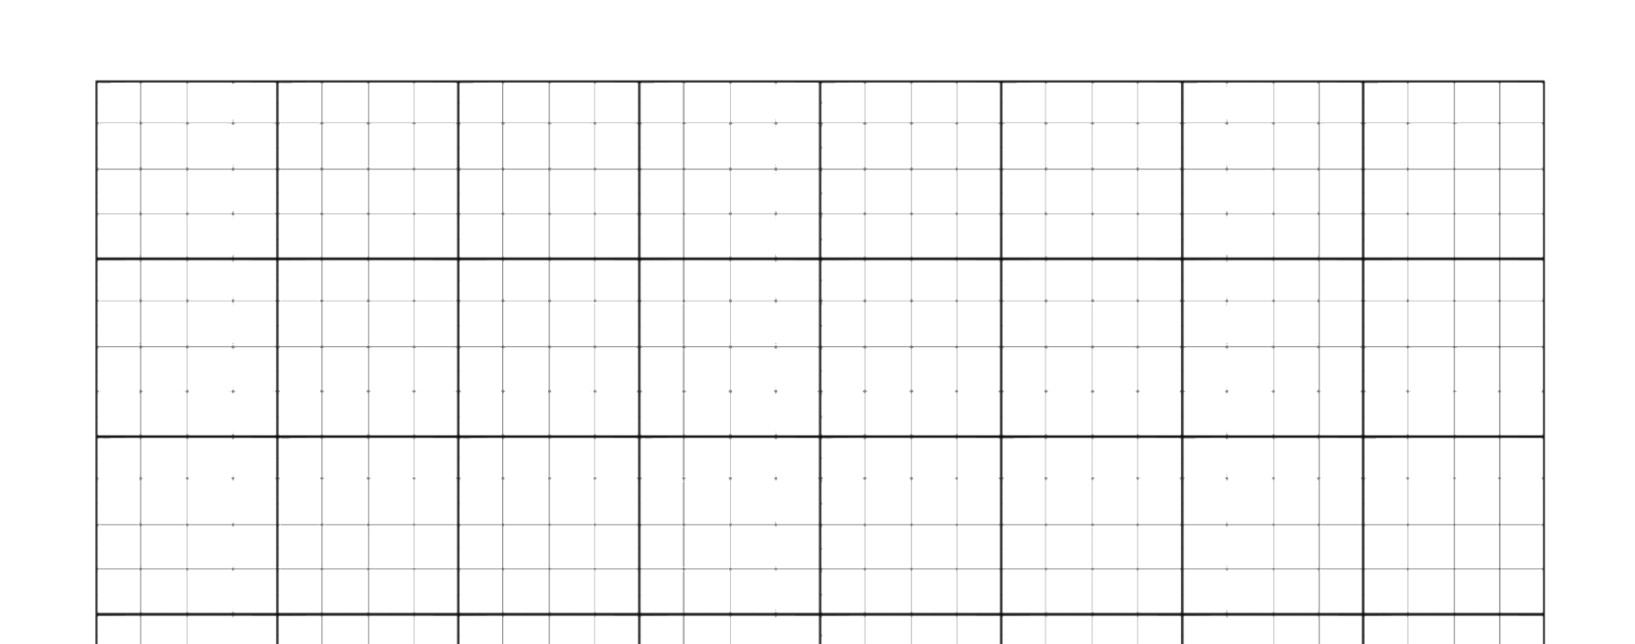

Graph Paper Notebook

Quad Grid Paper

101Planners.com

