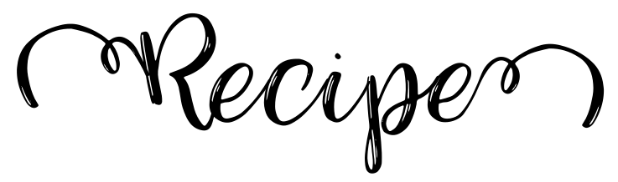
Title:
Ingredients: |  | Directions:

Photo:

