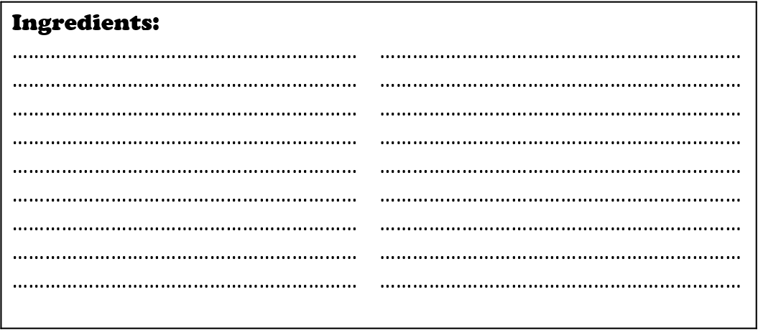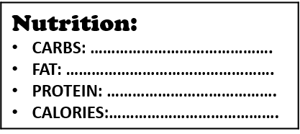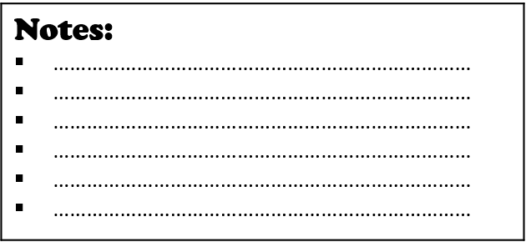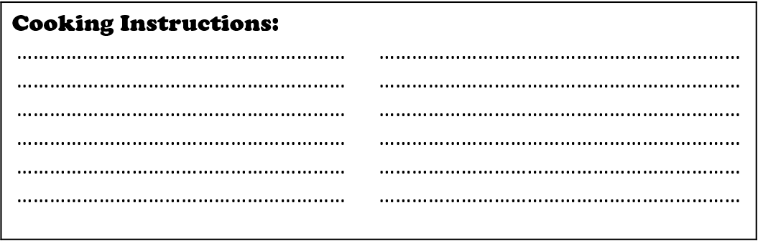

**:**……………………………………………………………..

DIFFICULTY: **o O O O** o PREP TIME: COOK TIME:

**7**