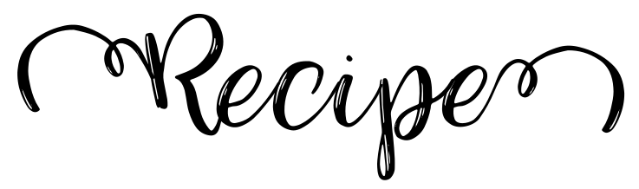
Title:
Ingredients: |  | Directions:
Title:
Ingredients: |  | Directions:

