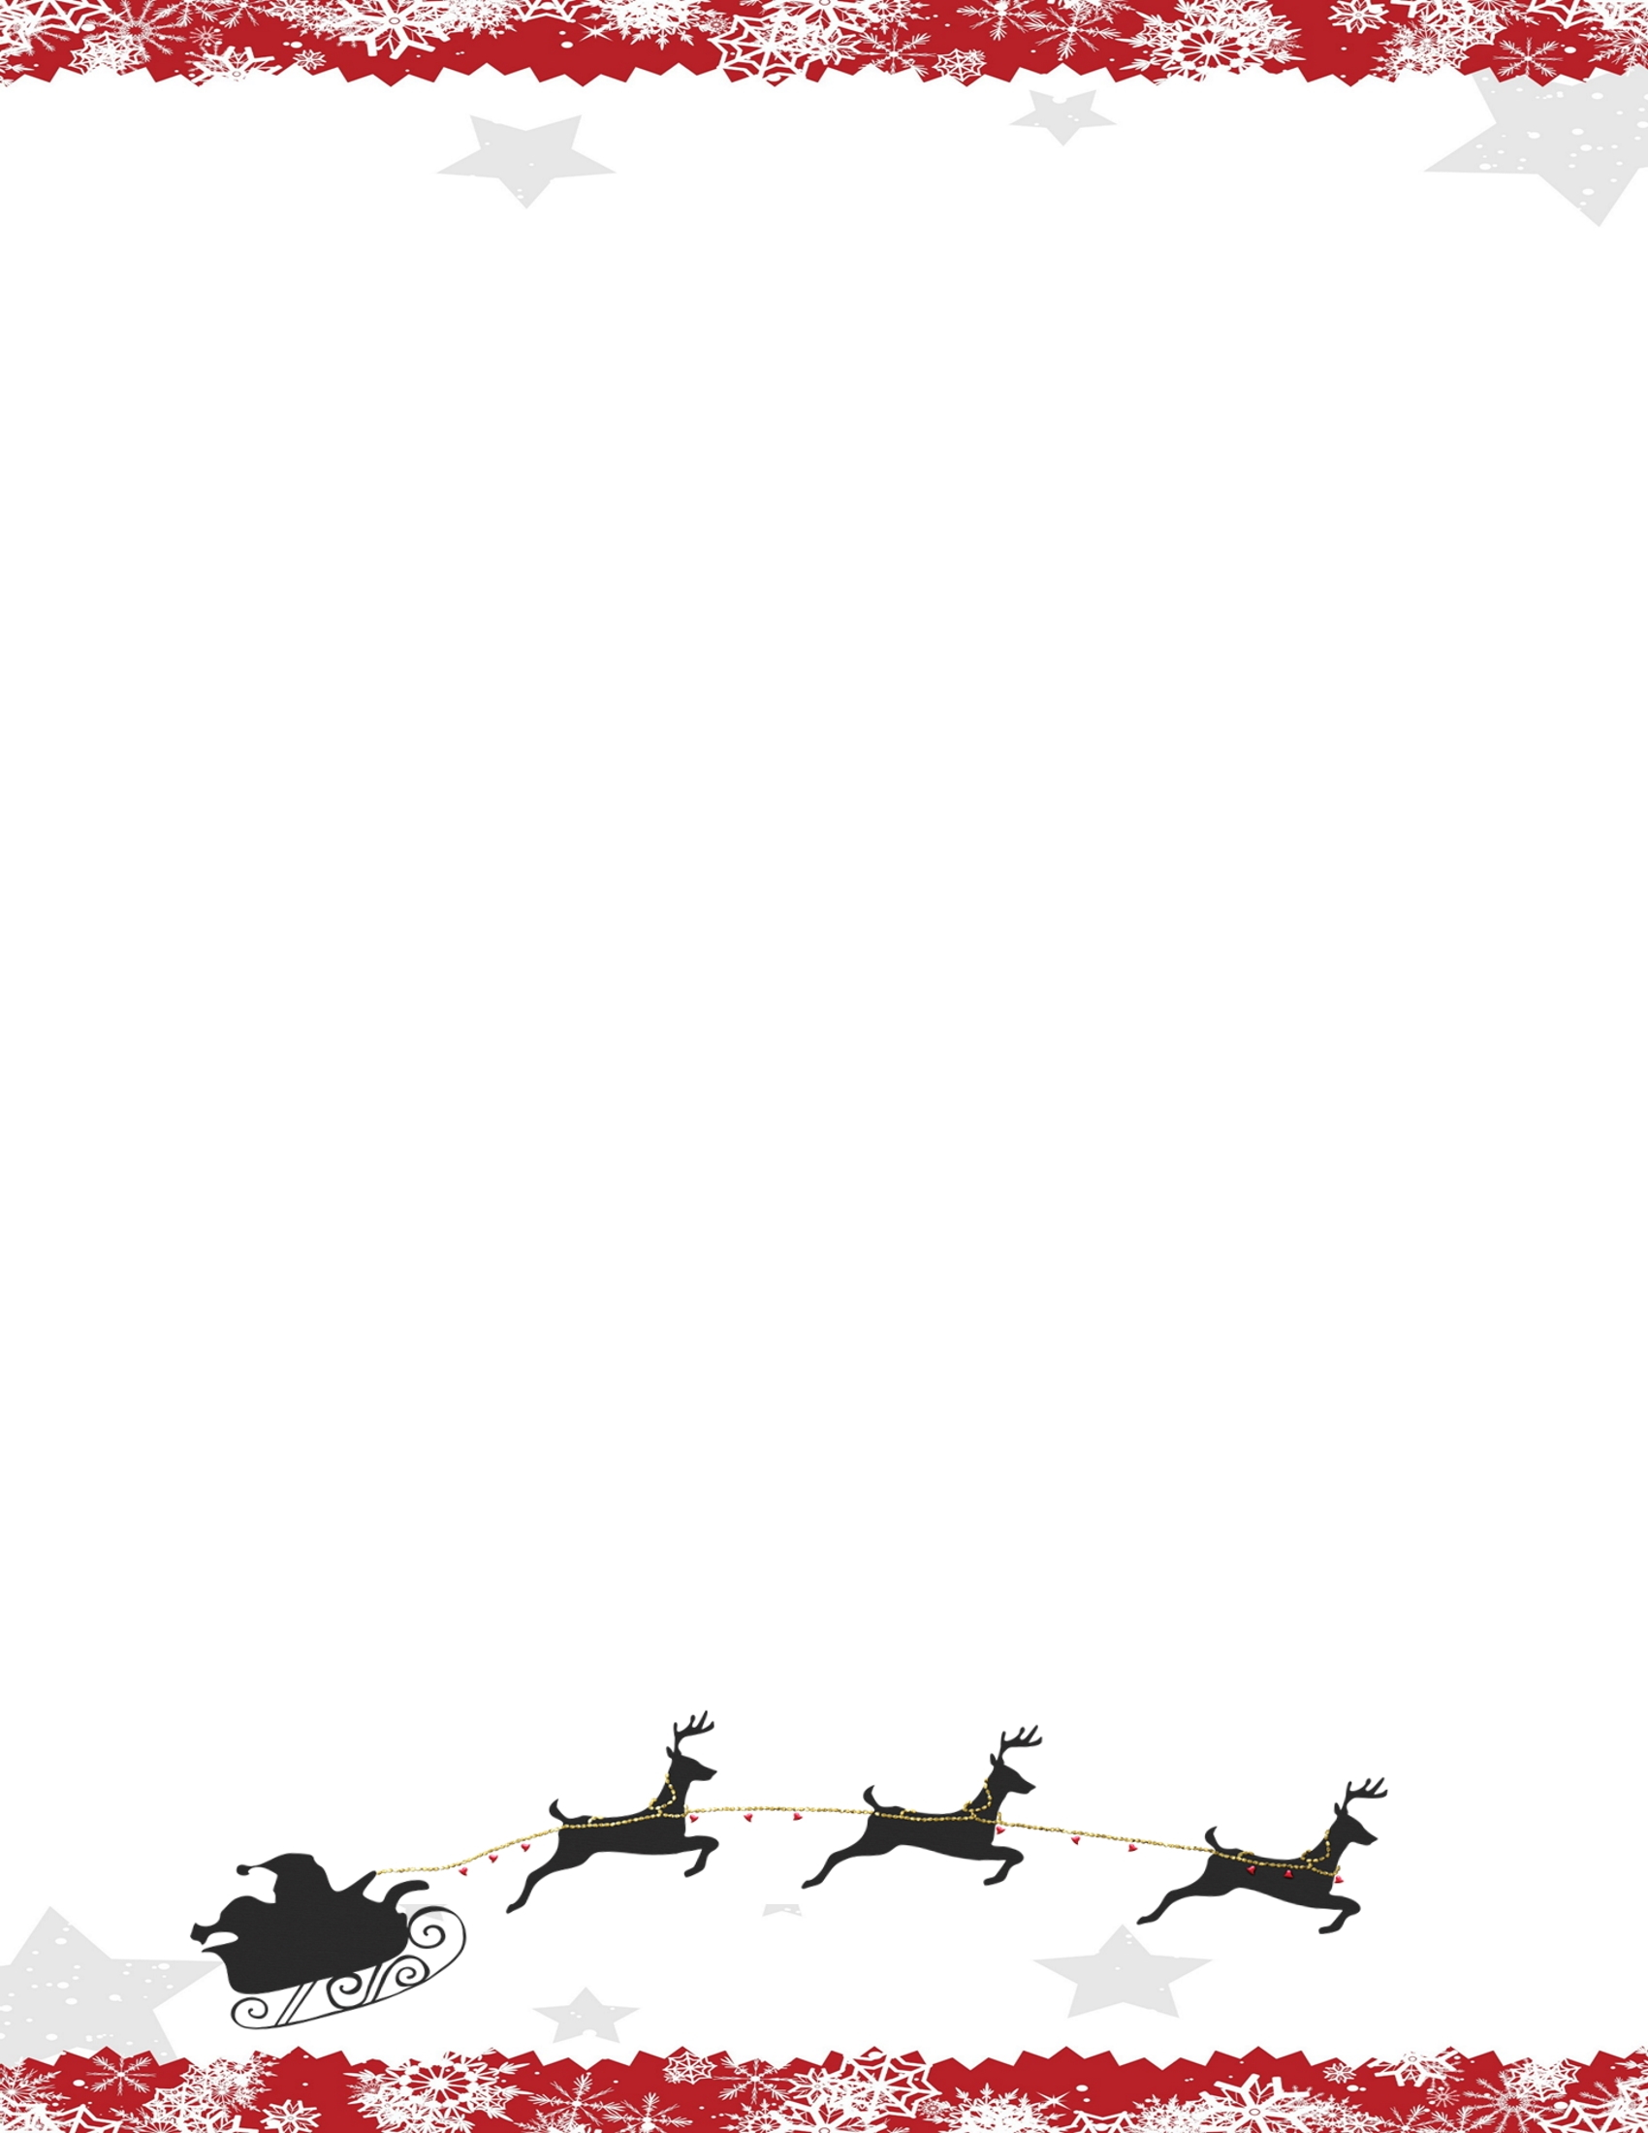

Dear    ,

I am Santa's little helper. As you prepare to kick start your holiday season, Santa has sent me an assignment to visit your home.

I watch and listen on behalf of Santa. I will leave every night and fly to the North Pole to tell Santa about your behavior.

Do you think what I see or hear will allow you to have gifts, or you will end up with cold coal?

During the day, I stay in my hiding place. Please do not touch me because I'll lose my magic.

Love, Elf