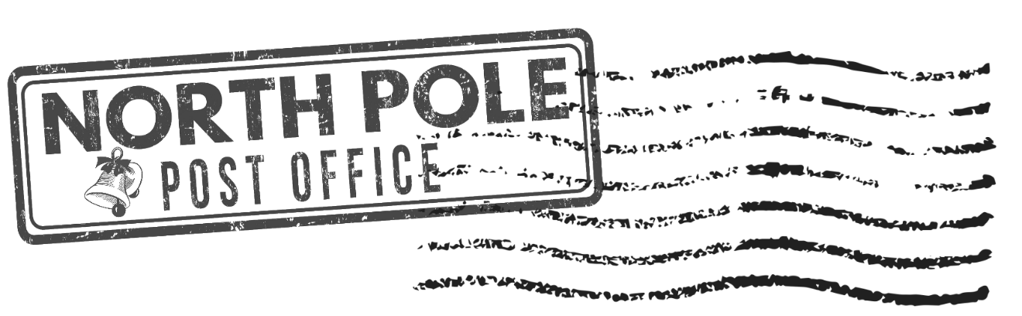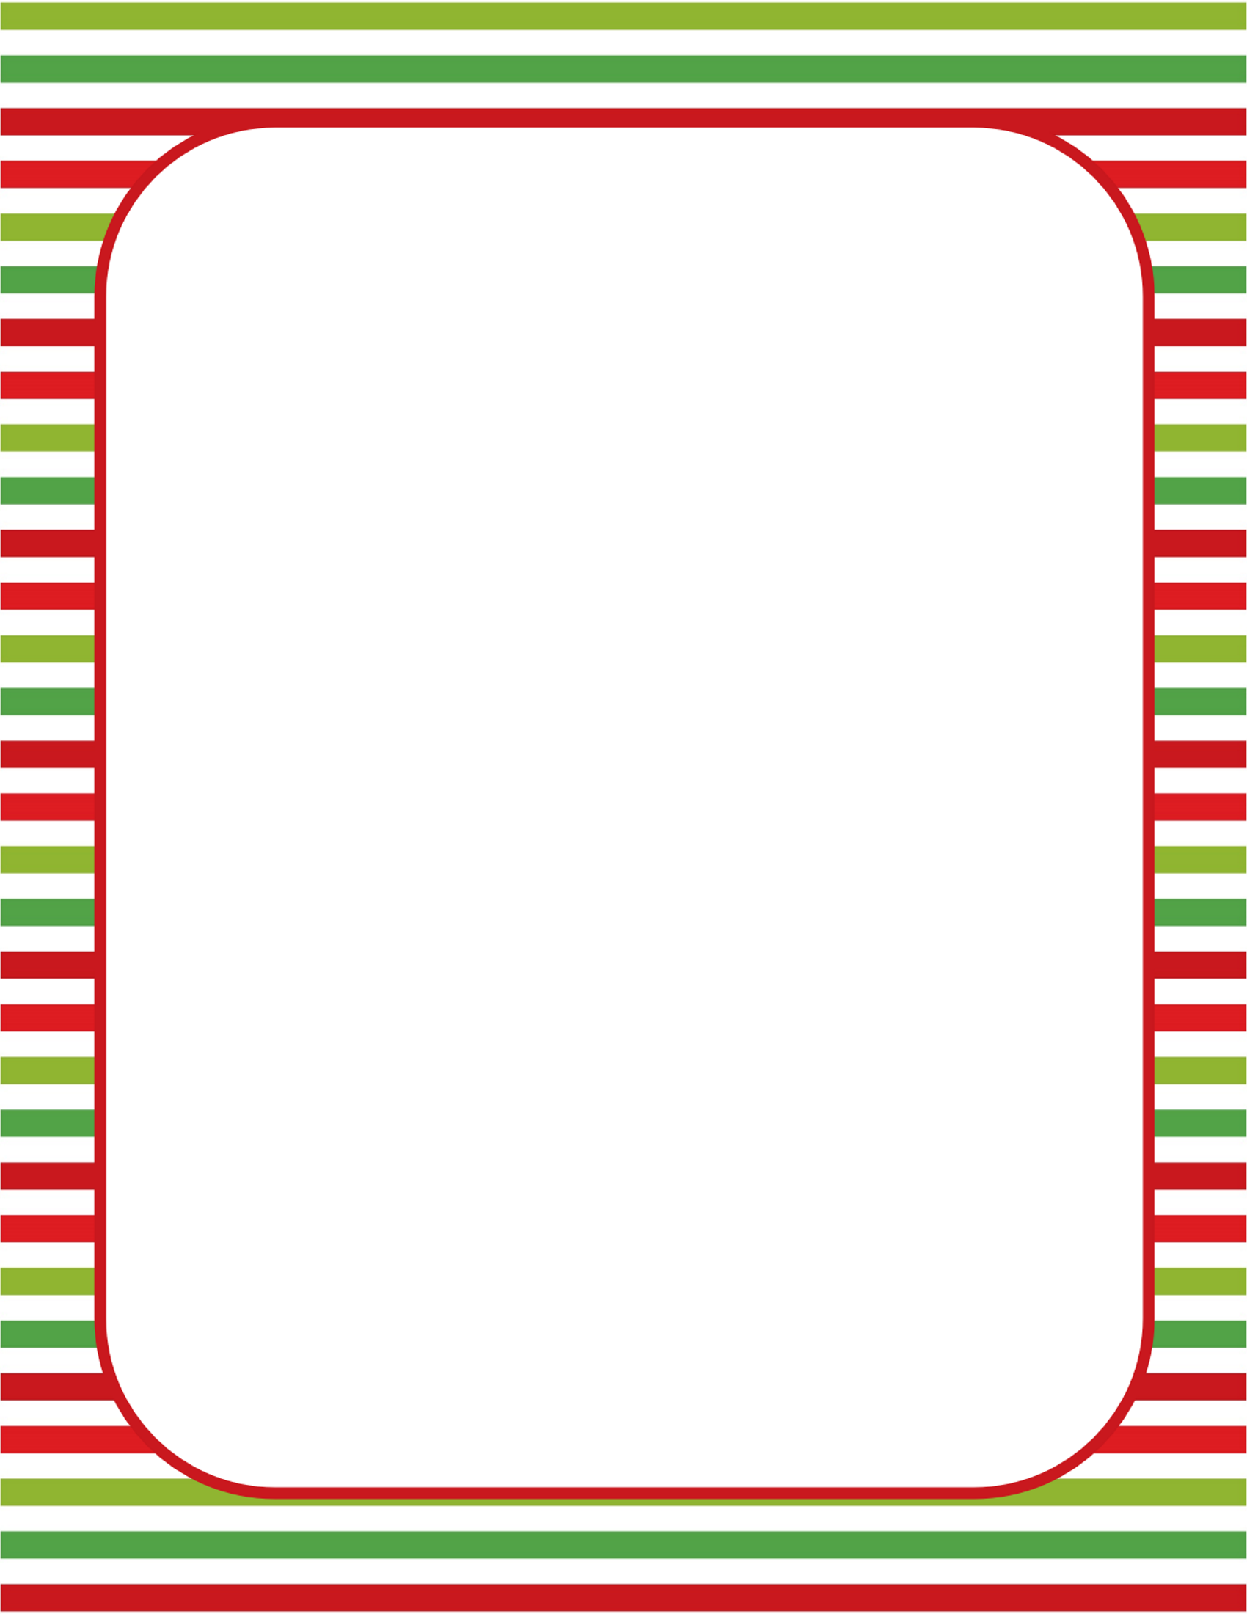

Dear      ,

It's me here from the North Pole. I am happy to inform you that I will be spending the next few weeks at your house.

Santa sent me here to keep an eye on everything you do or say to make sure you are obedient and kind. I will then report everything back and let Santa know how you are doing.

Remember, the number one rule is that you cannot touch me because it makes my magic flee.

I am ready and looking forward to sneaking on you every day.

Love,

Elf