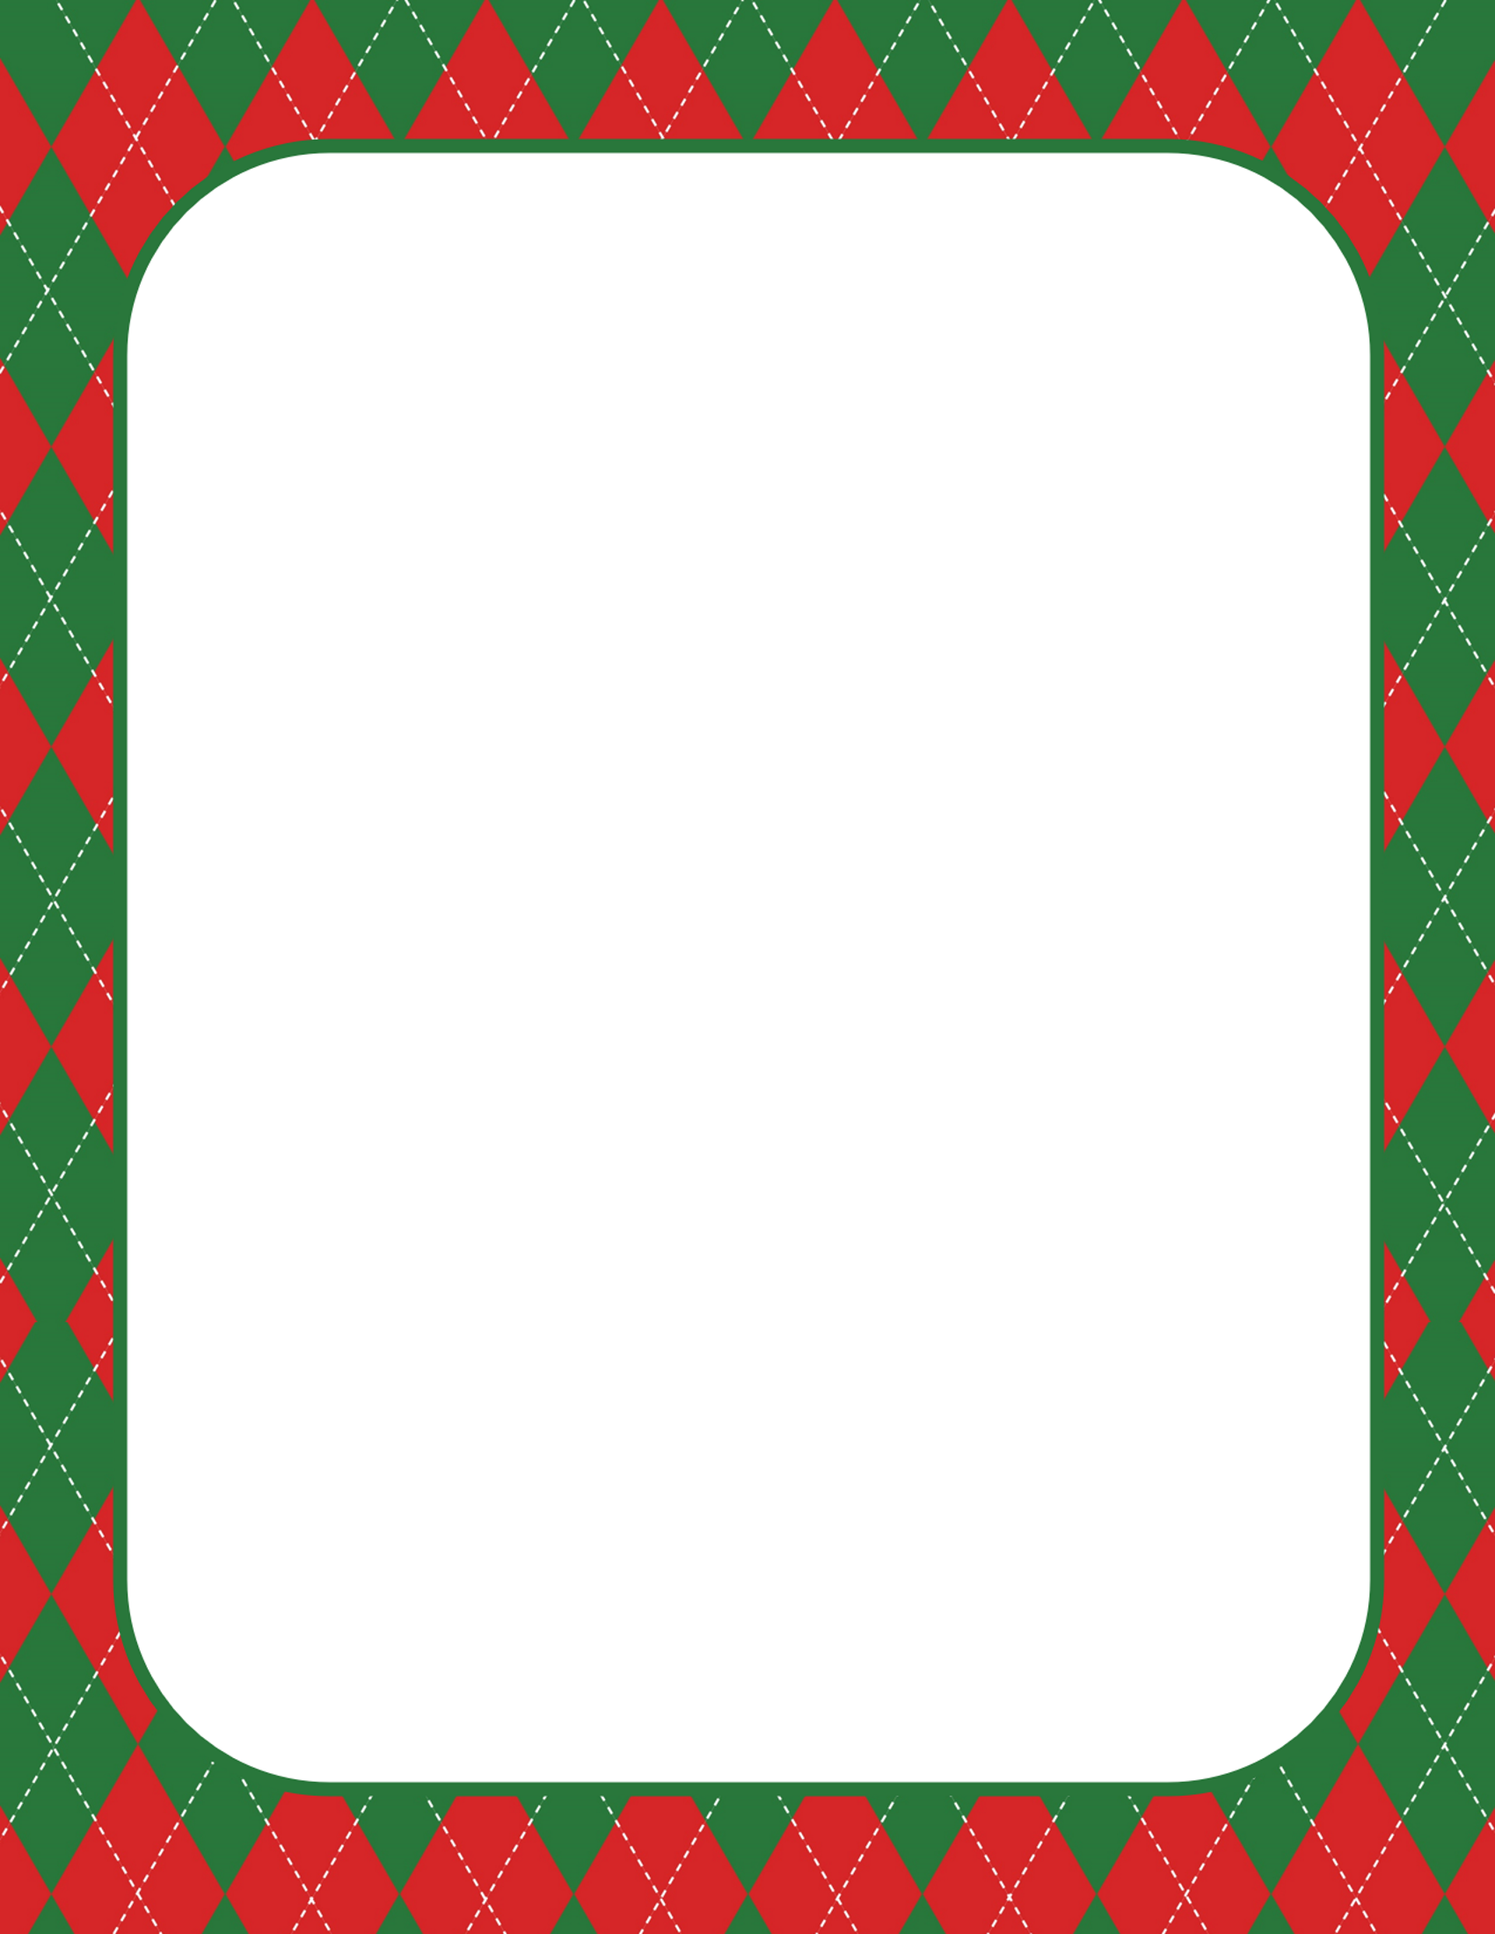

My time to leave has come, and I am not happy to say goodbye.

Living with you was so much fun, and I hope you won't cry.

I am excited and look forward to seeing you again next when you are taller than now.

I hope you will remain obedient and kind to everyone even when Christmas passes.

Show love and be friendly to others. Follow your heart and dreams throughout the year. Listen to your teachers and parents and follow their guidance.

Though I will be away, I will be thinking and watching over you.

Lots of Love from Elf