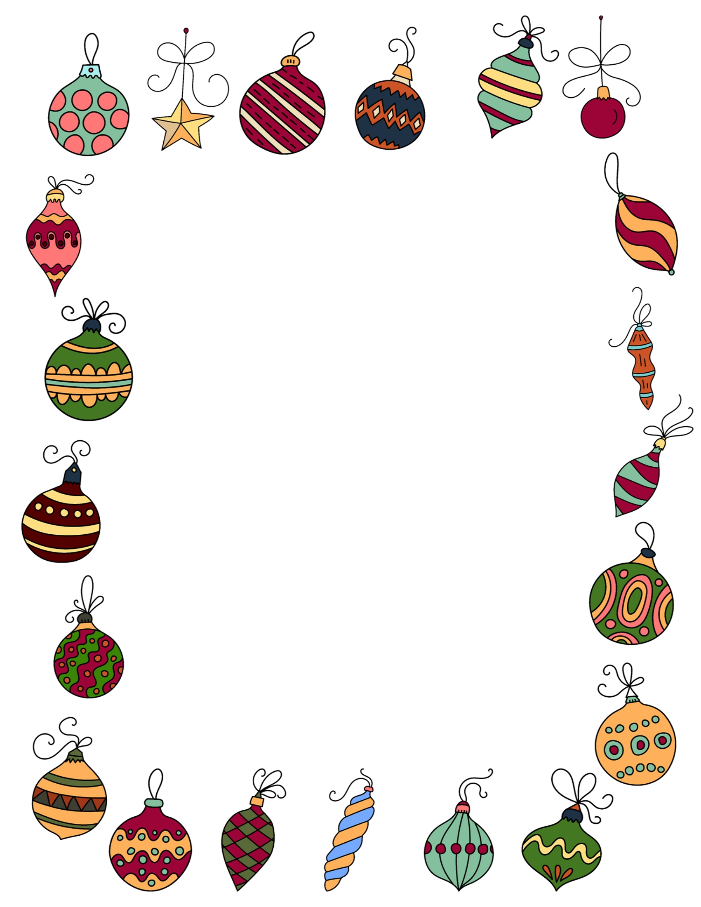

Dear       ,

I had so much fun living in your house. You are a happy family, and living with you was fun. If there are any messes I may have caused, it's because the fun was too much.

As much as I would like to stay longer in your house, it is not possible. I just hope you still remember why I visited your house and the true meaning of Christmas. This is the best time to embrace and show love to your family and friends. It leaves you with everlasting memories.

When you sleep tonight, you will experience some Christmas magic, and I will fly back to the North Pole. I will also be giving Santa my report before he sets off to distribute gifts. You will not find me in your home, but your gifts will be under the tree.

After reading this, you hug and bid me goodbye, and I hope to see you again next year. Bye for now.

Elfie