Attendance Chart

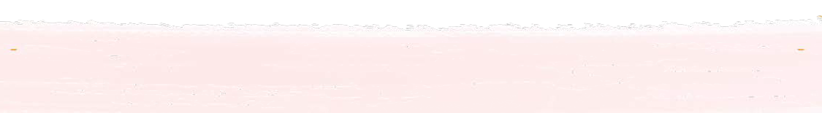

Date

**Student**