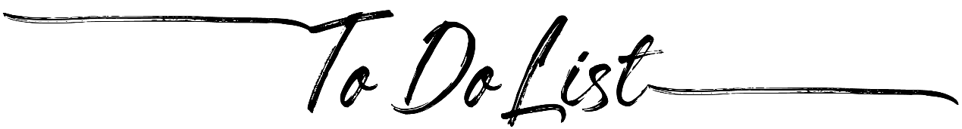

|  |  |  |  |  |
| --- | --- | --- | --- | --- |
| Done? | Task |  |  | Due |
|  |  |  |  |  |
|  |  |  |  |  |
|  |  |  |  |  |
|  |  |  |  |  |
|  |  |  |  |  |
|  |  |  |  |  |
|  |  |  |  |  |
|  |  |  |  |  |
|  |  |  |  |  |
|  |  |  |  |  |
|  |  |  |  |  |
|  |  |  |  |  |
|  |  |  |  |  |
|  |  |  |  |  |
|  |  |  |  |  |
|  |  |  |  |  |
|  |  |  |  |  |