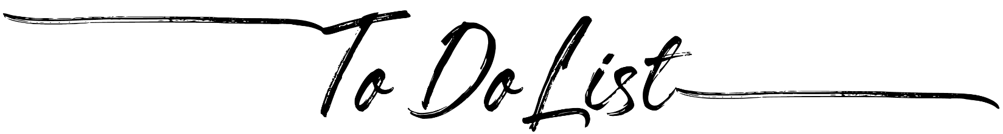
 | Task | Priority
1 |  | High | ☐ | Low | ☐
2 |  | High | ☐ | Low | ☐
3 |  | High | ☐ | Low | ☐
4 |  | High | ☐ | Low | ☐
5 |  | High | ☐ | Low | ☐
6 |  | High | ☐ | Low | ☐
7 |  | High | ☐ | Low | ☐
8 |  | High | ☐ | Low | ☐
9 |  | High | ☐ | Low | ☐
10 |  | High | ☐ | Low | ☐
11 |  | High | ☐ | Low | ☐
12 |  | High | ☐ | Low | ☐
13 |  | High | ☐ | Low | ☐
14 |  | High | ☐ | Low | ☐
15 |  | High | ☐ | Low | ☐
16 |  | High | ☐ | Low | ☐
17 |  | High | ☐ | Low | ☐
18 |  | High | ☐ | Low | ☐
19 |  | High | ☐ | Low | ☐
20 |  | High | ☐ | Low | ☐

