Daily Schedule |  |  |  | To Do
6:00
7:00
8:00
9:00
10:00
11:00
12:00
1:00
2:00
3:00
4:00
5:00
6:00
7:00
8:00
9:00

meals hydration
Breakfast
Lunch
Dinner |  |  |  |  | 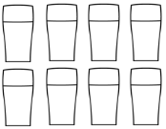
Snack/s

Exercise reflection

