Daily Schedule |  |  |  | Mood:
 |  |  |  | 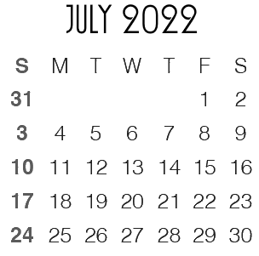
6:00 |  |  |  |  | 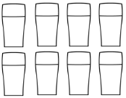
7:00
8:00
9:00
10:00
11:00 |  |  |  |  | To Do
12:00
1:00
2:00
3:00
4:00
5:00
6:00
7:00
8:00
9:00

Notes Meals
Breakfast:
Lunch:
Dinner:
Snacks:

Gratitude Reflection

