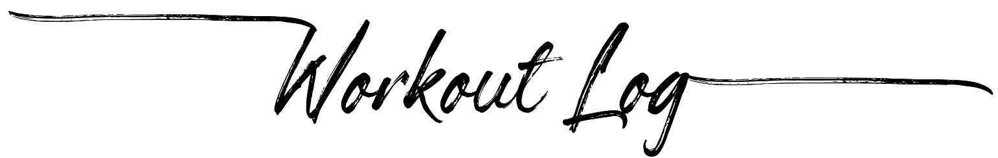
Exercise | Notes | Reps | Weight | # Weeks | Frequency | Start | Finish

