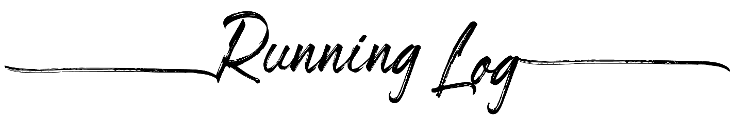
Pace | Time | Distance | Goal | Date

