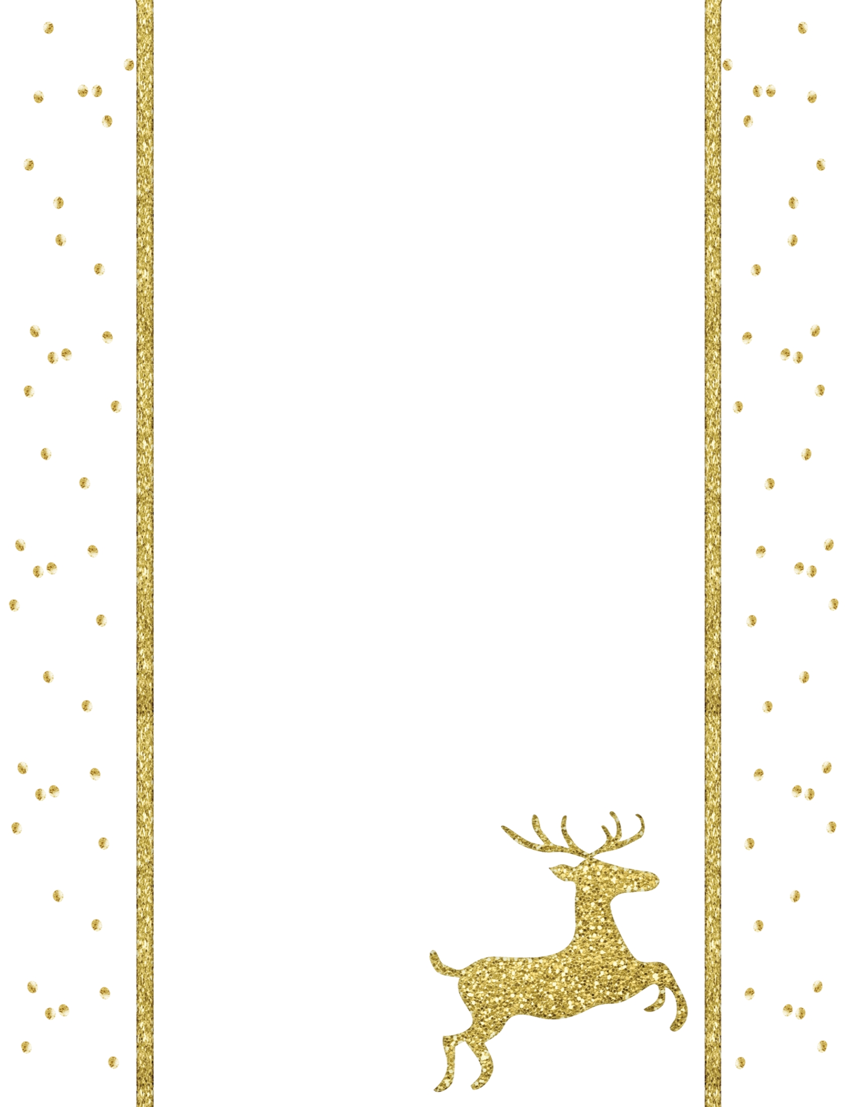

Dear Santa,

**Letter to Santa**