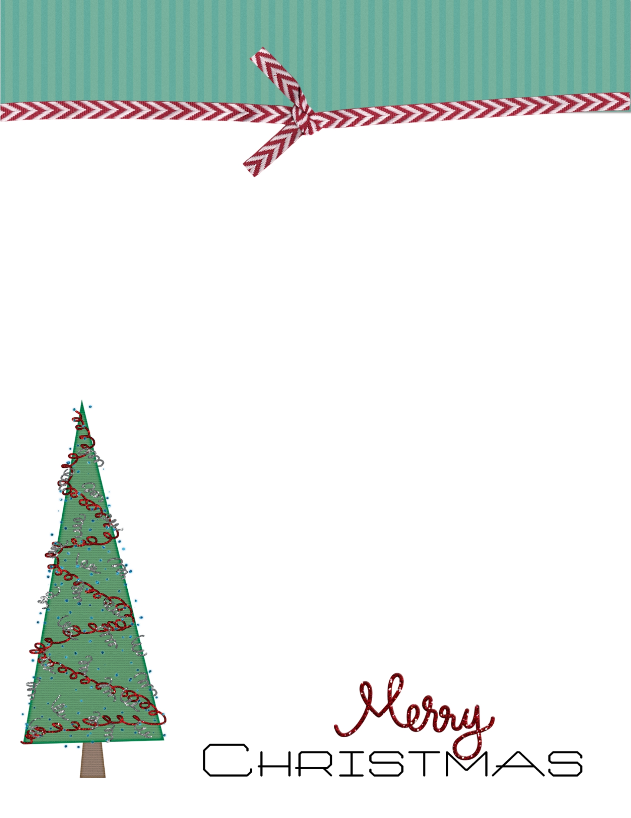

**Letter to Santa**

Dear Santa,