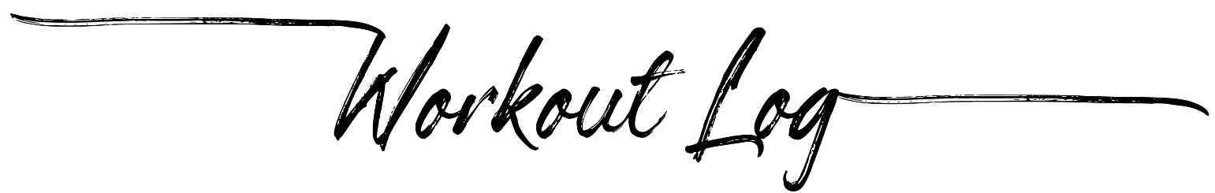
 |  |  |  | Date:
 |  | Planned |  | Actual |  | Complete Workout?
Exercise | Notes | Reps | Weight | Reps | Weight
 |  |  |  |  |  | Yes |  | No | 
 |  |  |  |  |  | Yes |  | No | 
 |  |  |  |  |  | Yes |  | No | 
 |  |  |  |  |  | Yes |  | No | 
 |  |  |  |  |  | Yes |  | No | 
 |  |  |  |  |  | Yes |  | No | 
 |  |  |  |  |  | Yes |  | No | 
 |  |  |  |  |  | Yes |  | No | 
 |  |  |  |  |  | Yes |  | No | 
 |  |  |  |  |  | Yes |  | No | 
 |  |  |  |  |  | Yes |  | No | 
 |  |  |  |  |  | Yes |  | No | 
 |  |  |  |  |  | Yes |  | No | 
 |  |  |  |  |  | Yes |  | No | 

