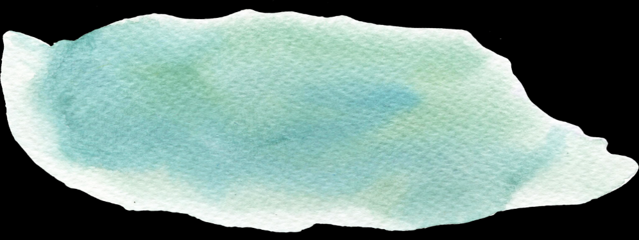

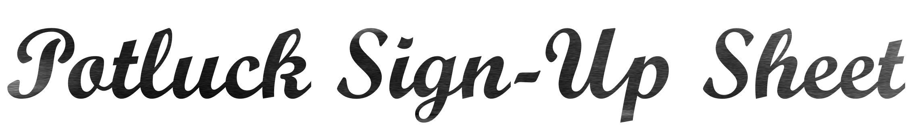

|  |  |  |
| --- | --- | --- |
| Name | I will bring: | Contact Details |
|  |  |  |
|  |  |  |
|  |  |  |
|  |  |  |
|  |  |  |
|  |  |  |
|  |  |  |
|  |  |  |
|  |  |  |
|  |  |  |
|  |  |  |
|  |  |  |
|  |  |  |
|  |  |  |
|  |  |  |
|  |  |  |
|  |  |  |