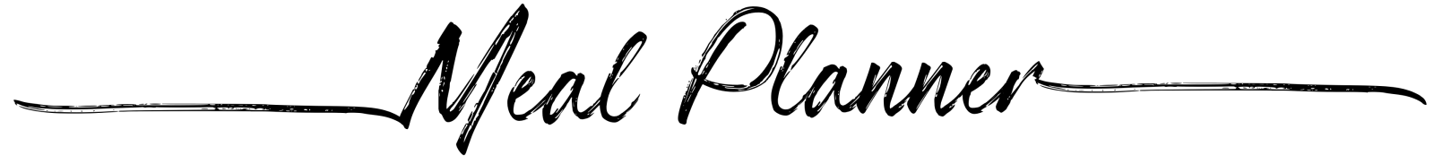
S | Breakfast | Lunch | Dinner | 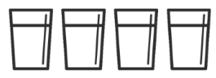
M | Breakfast | Lunch | Dinner
T | Breakfast | Lunch | Dinner
W | Breakfast | Lunch | Dinner
T | Breakfast | Lunch | Dinner
F | Breakfast | Lunch | Dinner
S | Breakfast | Lunch | Dinner

