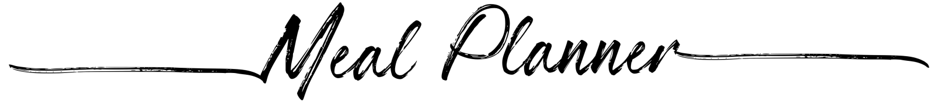
 | Breakfast | Lunch | Dinner | Snacks | 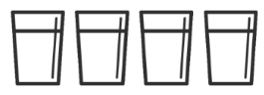
 | Breakfast | Lunch | Dinner | Snacks
 | Breakfast | Lunch | Dinner | Snacks
 | Breakfast | Lunch | Dinner | Snacks
 | Breakfast | Lunch | Dinner | Snacks
 | Breakfast | Lunch | Dinner | Snacks
 | Breakfast | Lunch | Dinner | Snacks

