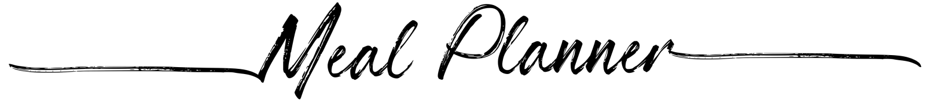

|  |  |  |  |  |
| --- | --- | --- | --- | --- |
|  |  | | | |
|  | Breakfast | Lunch | Dinner |  |
|  |  | | | |
|  | Breakfast | Lunch | Dinner |  |
|  |  | | | |
|  | Breakfast | Lunch | Dinner |  |
|  |  | | | |
|  | Breakfast | Lunch | Dinner |  |
|  |  | | | |
|  | Breakfast | Lunch | Dinner |  |
|  |  | | | |
|  | Breakfast | Lunch | Dinner |  |
|  |  | | | |
|  | Breakfast | Lunch | Dinner |  |